SLOW-COOKED BBQ PORK RIBS  COOK TIME: 4 hours on high or 8 hours on low  SOURCE: Unknown  #pork #American #slow-cook | 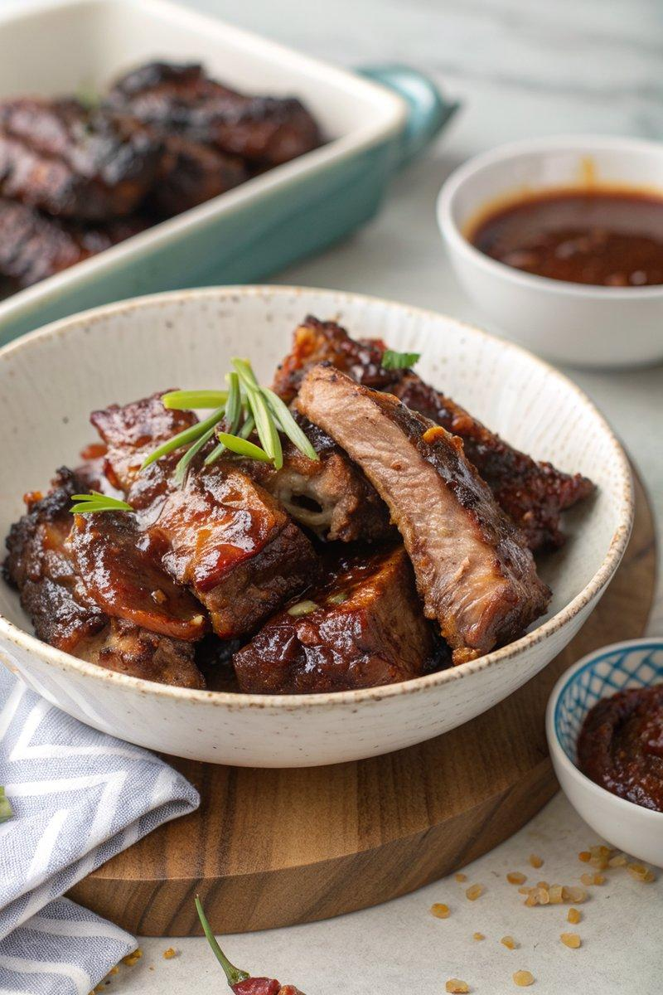

INGREDIENTS  - {'group': 'Main', 'item': '2 racks of pork ribs'}  - {'group': 'Sauce', 'item': '2 tbsp cider vinegar'}  - {'group': 'Sauce', 'item': '150g smoky barbecue sauce'}  - {'group': 'Sauce', 'item': '2 tbsp Worcestershire sauce'}  - {'group': 'Sauce', 'item': '100ml chicken stock'}  - {'group': 'Spice Rub', 'item': '2 tsp smoked paprika'}  - {'group': 'Spice Rub', 'item': '1 tbsp light brown soft sugar'}  - {'group': 'Spice Rub', 'item': '1 tsp salt'}  - {'group': 'Spice Rub', 'item': '1 tsp dried mixed herbs'}  - {'group': 'Spice Rub', 'item': '1 tsp garlic granules'}  - {'group': 'Spice Rub', 'item': '1 tsp onion powder'}  - {'group': 'Spice Rub', 'item': '1/2 tsp hot chilli powder'} | PREP  Combine all spice rub ingredients in a small bowl. Massage the rub into both sides of the pork ribs. If necessary, cut ribs to fit into the slow cooker. Cover and marinate in the fridge for at least 1 hour, preferably overnight.  COOK  Mix cider vinegar, barbecue sauce, Worcestershire sauce, and chicken stock in a jug. Place ribs in the slow cooker and pour the sauce mixture over them, ensuring they are well coated. Cook on high for 4 hours or on low for 8 hours until the meat is tender and falling off the bone. Preheat the oven to 200°C (180°C (350°F (175°C)) fan). Transfer ribs to an ovenproof tray, brush with juices from the slow cooker, and bake for 10-15 minutes until they develop a sticky glaze.  PLATING  Serve the ribs hot, accompanied by roasted sweet potatoes and a simple slaw for a complete meal.

NOTES:
For the roasted sweet potatoes, peel and cube them, toss with oil, salt, pepper, and cumin seeds, then roast at 200°C (400°F (200°C)) for 35-40 minutes. For the slaw, mix thinly sliced red cabbage, grated carrot, and sliced red onion with mayonnaise.

