SLOW-COOKED PORK WITH APPLE CIDER SAUCE  COOK TIME: 10 hrs  SOURCE: Unknown  #pork #British #slow-cook | 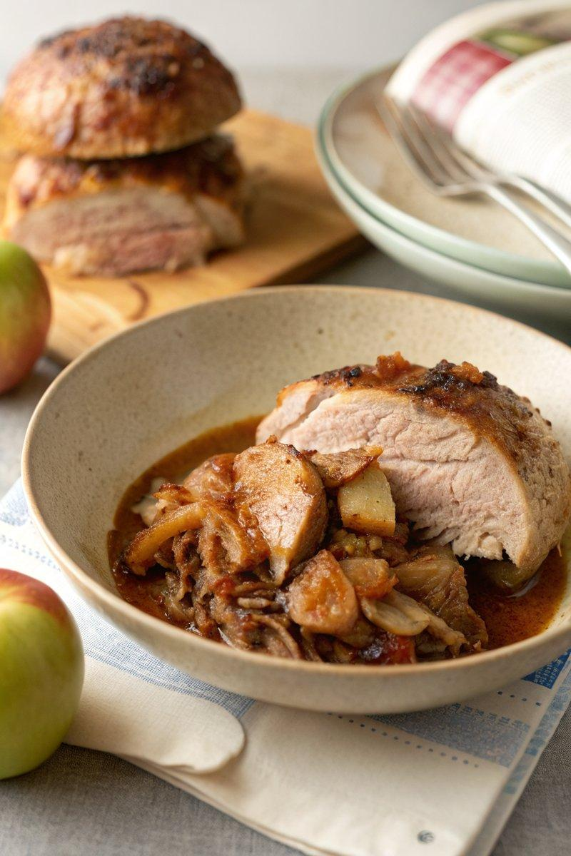

INGREDIENTS  - {'group': 'Main', 'item': '2kg boneless pork shoulder'}  - {'group': 'Main', 'item': '2 onions, peeled and quartered'}  - {'group': 'Main', 'item': '2 Granny Smith apples, peeled, cored, and quartered'}  - {'group': 'Main', 'item': '200ml dry cider or apple juice'}  - {'group': 'Sauce', 'item': '1 tbsp red wine vinegar'}  - {'group': 'Sauce', 'item': '150g dark brown soft sugar'}  - {'group': 'Sauce', 'item': '1 tsp chilli flakes'}  - {'group': 'Sauce', 'item': '75ml apple juice'}  - {'group': 'Sauce', 'item': '1 tbsp runny honey'}  - {'group': 'For Serving', 'item': '4-6 soft baps or buns'}  - {'group': 'Rub', 'item': '1 tbsp smoked paprika'}  - {'group': 'Rub', 'item': '½ tbsp ground cumin'}  - {'group': 'Rub', 'item': '1½ tsp salt'}  - {'group': 'Rub', 'item': 'Plenty of cracked black pepper'}  - {'group': 'Rub', 'item': '1 tsp garlic granules'}  - {'group': 'Rub', 'item': '1 tsp fennel seeds'}  - {'group': 'Rub', 'item': '1 tbsp dried mixed herbs'} | PREP  Mix the smoked paprika, ground cumin, salt, black pepper, garlic granules, fennel seeds, and dried mixed herbs in a small bowl. Rub this mixture all over the pork shoulder, ensuring it is well coated.  COOK  Place the onions and apples at the bottom of the slow-cooker. Position the seasoned pork on top and pour the cider around the sides, avoiding the top of the pork. Cover and cook on low for 10 hours until the pork is tender. Strain the cooking juices into a saucepan, discarding the apples after mashing them with a fork. Add the mashed apples, red wine vinegar, dark brown sugar, chilli flakes, apple juice, and honey to the saucepan. Stir and bring to a simmer over medium-high heat, cooking until thick and glossy, about 10 minutes.  PLATING  Remove the skin from the pork and either carve or shred it. Serve in baps with the cooked onions and generous amounts of the apple cider sauce.

NOTES:
For an extra touch, serve with sage and onion stuffing or seared Brussels sprouts. To prepare the sprouts, halve them and sear in a hot pan with oil until browned, then toss with cooked bacon lardons and a splash of chicken stock.

