SLOW-COOKED PORK AND BEEF MEATBALLS  COOK TIME: 3 hours  SOURCE: Unknown  #pork #beef #Italian #slow-cook | 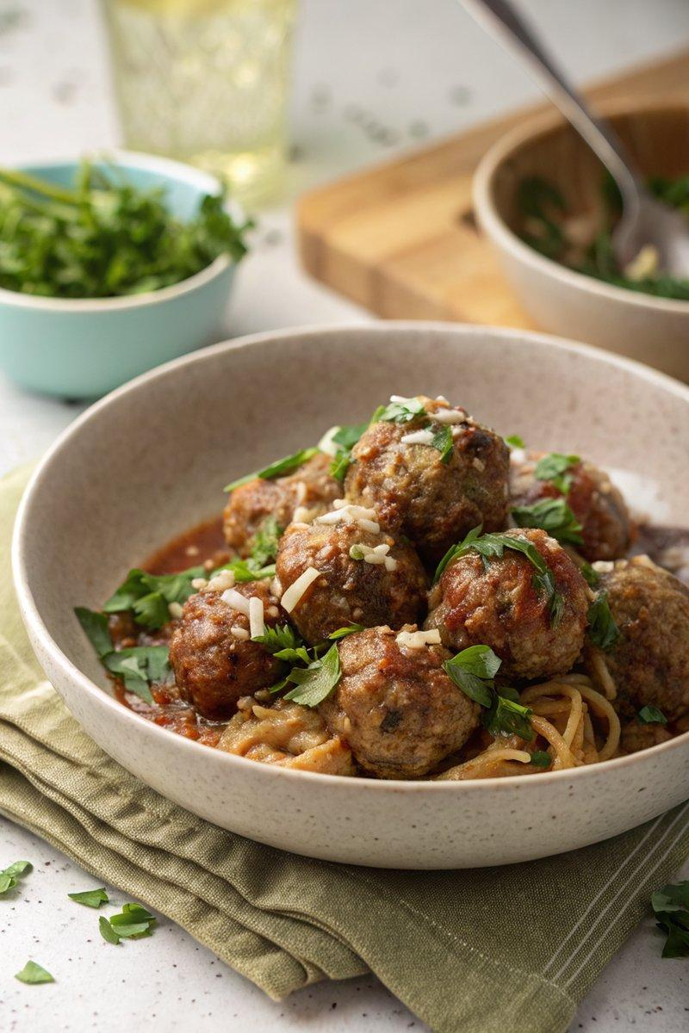

INGREDIENTS  - {'group': 'Main', 'item': '250g pork mince'}  - {'group': 'Main', 'item': '250g beef mince'}  - {'group': 'Main', 'item': '2 garlic cloves, crushed'}  - {'group': 'Main', 'item': '1 egg'}  - {'group': 'Main', 'item': 'small handful of flat-leaf parsley, roughly chopped'}  - {'group': 'Main', 'item': '2 slices of bread, crusts discarded, torn into small pieces'}  - {'group': 'Main', 'item': 'whole milk, enough to soak bread'}  - {'group': 'Main', 'item': 'salt and black pepper'}  - {'group': 'Sauce', 'item': '2x 400g cans of plum tomatoes'}  - {'group': 'Sauce', 'item': '1 tbsp tomato purée'}  - {'group': 'Sauce', 'item': '6 garlic cloves, crushed'}  - {'group': 'Sauce', 'item': 'small handful of basil, a few leaves reserved'}  - {'group': 'Sauce', 'item': '2 tbsp olive oil'}  - {'group': 'Sauce', 'item': '½ tsp white sugar, if needed'}  - {'group': 'For Serving', 'item': 'spaghetti, cooked to packet instructions'}  - {'group': 'For Serving', 'item': 'grated parmesan'}  - {'group': 'For Serving', 'item': 'green salad'} | PREP  Soak the bread pieces in enough milk to cover them in a small bowl for about 10 minutes. In a large bowl, combine the pork mince, beef mince, 2 crushed garlic cloves, egg, and parsley. Season generously with salt and pepper. Squeeze out excess milk from the bread and add it to the meat mixture. Mix thoroughly using your hands until well combined.  COOK  Shape the mixture into 12-16 meatballs and place them on a plate. Chill in the fridge while preparing the sauce. In the slow cooker, combine the plum tomatoes, squishing them as they go in, with tomato purée, 6 crushed garlic cloves, basil, olive oil, and 1 tsp each of salt and pepper. Cook on high for 2 hours until the sauce is glossy and fragrant. Adjust seasoning with sugar if needed. Add the meatballs to the sauce, reshaping them gently, and cook on high for an additional hour until tender.  PLATING  Serve the meatballs over cooked spaghetti, topped with grated parmesan and reserved basil leaves. Accompany with a green salad.

NOTES:
For a Mediterranean twist, consider adding anchovies, black olives, and roasted red peppers to the sauce. Meatballs can be frozen raw for up to 6 months.

