HEARTY PORK SAUSAGE CASSEROLE  COOK TIME: 4 hrs  SOURCE: Unknown  #pork #european #slow-cook | 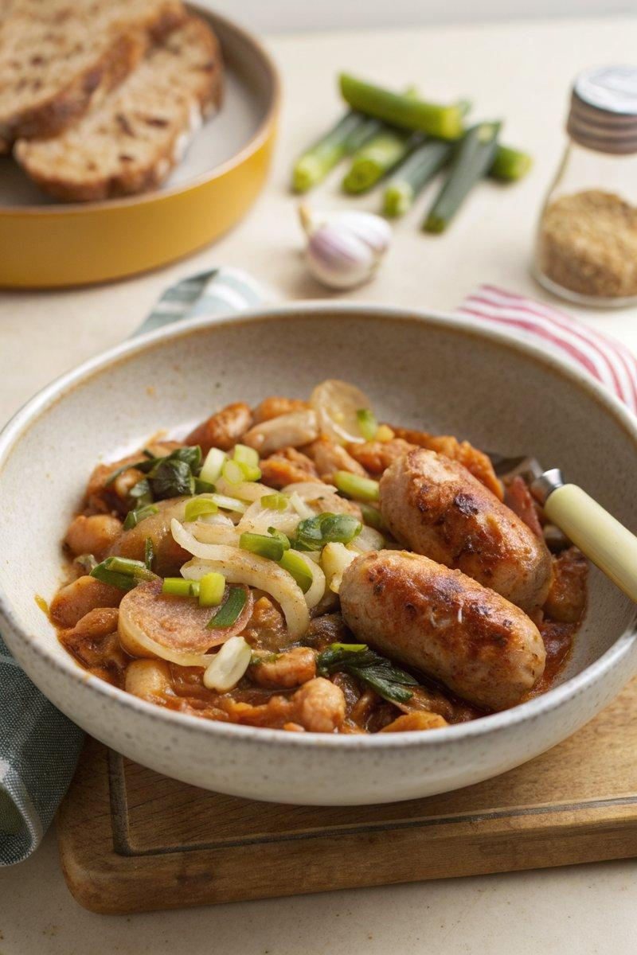

INGREDIENTS  - {'group': 'Main', 'item': '800g pork sausages, halved'}  - {'group': 'Main', 'item': '1 onion, sliced'}  - {'group': 'Main', 'item': '2 celery sticks, thickly sliced'}  - {'group': 'Main', 'item': '4 garlic cloves, grated or crushed'}  - {'group': 'Main', 'item': '1 tsp fennel seeds'}  - {'group': 'Main', 'item': '2 bay leaves'}  - {'group': 'Main', 'item': '2 tbsp tomato purée'}  - {'group': 'Main', 'item': '2 x 400g cans cannellini beans, drained'}  - {'group': 'Main', 'item': '200ml white or light red wine'}  - {'group': 'Main', 'item': '1 chicken stock cube, crumbled'}  - {'group': 'Main', 'item': '200g cavolo nero, sliced'}  - {'group': 'Seasoning', 'item': 'salt and black pepper'}  - {'group': 'Garnish', 'item': 'grated parmesan or pecorino'}  - {'group': 'Garnish', 'item': 'extra-virgin olive oil'} | PREP  Slice the sausages in half or quarters if large. Prepare the onion, celery, and garlic by slicing and grating as needed. Drain the cannellini beans and slice the cavolo nero.  COOK  In a slow cooker, combine the sausages, onion, celery, garlic, fennel seeds, bay leaves, tomato purée, cannellini beans, wine, and crumbled chicken stock cube. Season with 1 tsp of salt and a generous amount of black pepper. Stir well, cover, and cook on high for 4 hours. With 15-20 minutes remaining, add the cavolo nero and continue cooking until wilted.  PLATING  Serve the casserole hot, topped with grated parmesan or pecorino and a drizzle of extra-virgin olive oil. Pair with crusty bread for a complete meal.

NOTES:
For a vegetarian version, substitute pork sausages with vegetarian sausages and use a vegetable stock cube.

