HONEY-GLAZED SAUSAGES IN BACON  COOK TIME: 1 hr  SOURCE: Unknown  #pork #American #slow-cook | 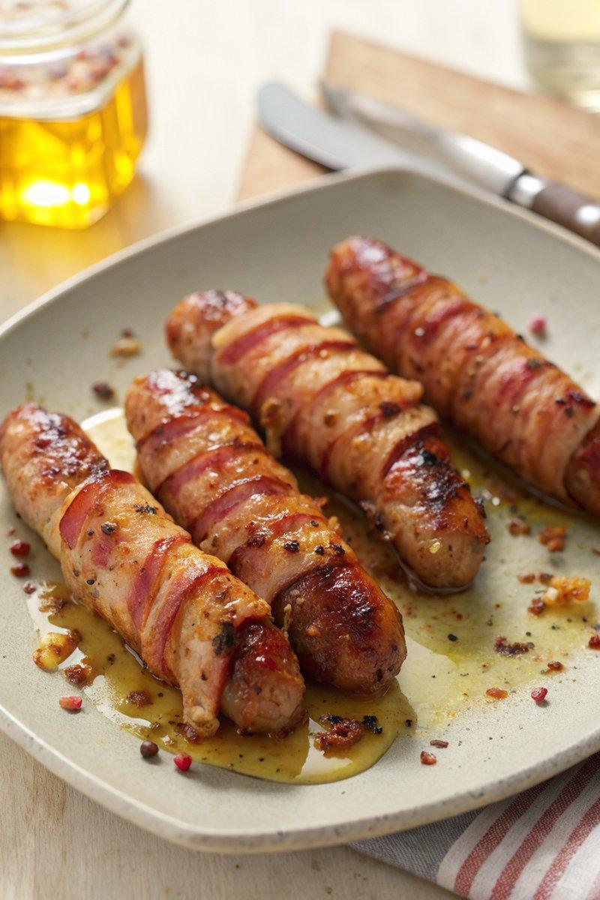

INGREDIENTS  - {'group': 'Main', 'item': '10 rashers smoked streaky bacon'}  - {'group': 'Main', 'item': '10 chipolatas'}  - {'group': 'Sauce', 'item': '3 tbsp runny honey or maple syrup'}  - {'group': 'Sauce', 'item': '1 tsp chilli flakes'}  - {'group': 'Sauce', 'item': '1 garlic clove, grated or crushed'}  - {'group': 'Seasoning', 'item': '½ tbsp dark brown soft sugar'}  - {'group': 'Seasoning', 'item': 'Salt and black pepper'}  - {'group': 'Other', 'item': 'Oil, for greasing'} | PREP  Wrap each chipolata with a rasher of smoked streaky bacon and secure with a cocktail stick. Lightly grease the bottom of the slow-cooker bowl with oil to prevent sticking.  COOK  In a small saucepan, combine honey or maple syrup, chilli flakes, and garlic. Heat over medium-high until aromatic, then let it bubble gently for a few minutes. Arrange the bacon-wrapped sausages in a single layer in the slow-cooker. Brush with some of the hot honey mixture, sprinkle with brown sugar, and season with salt and pepper. Cover and cook on high for 1 hour until the sausages are cooked through and the glaze is sticky.  PLATING  Before serving, brush the sausages with the remaining honey glaze for extra stickiness and flavour.

NOTES:
These sausages can be served as a side with a roast dinner or as a snack. For smaller servings, use cocktail sausages and halve the bacon rashers.

