SLOW-COOKED JACK DANIEL'S PULLED PORK  COOK TIME: 5 hours on high or 8-10 hours on low  SOURCE: Unknown  #pork #American #slow-cook | 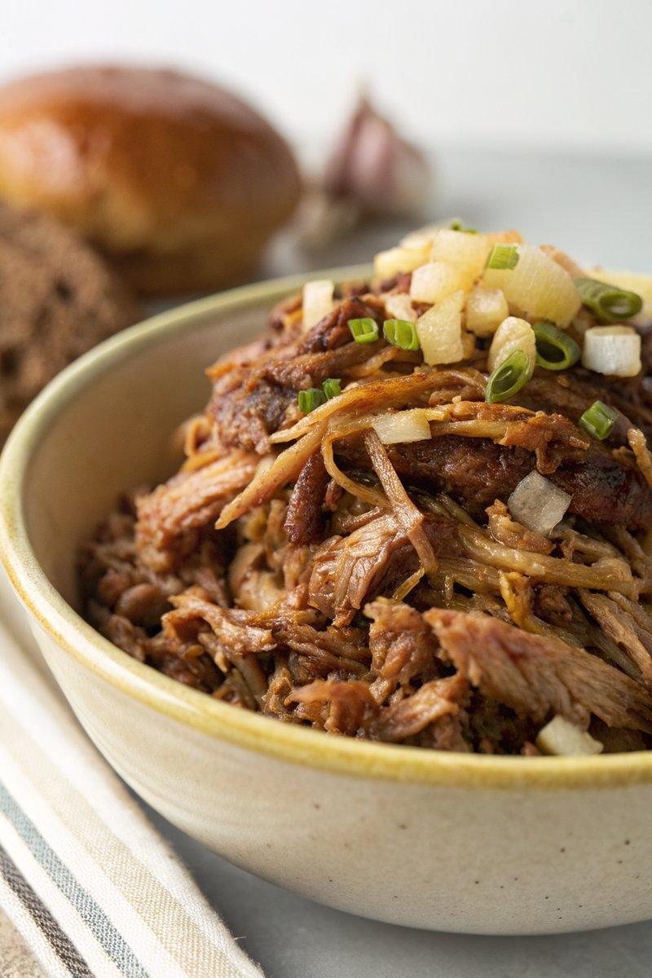

INGREDIENTS  - {'group': 'Main', 'item': '800g skinless, boneless pork shoulder, diced'}  - {'group': 'Main', 'item': '300g banana shallots, finely chopped'}  - {'group': 'Main', 'item': '1 bulb of garlic, cloves separated and grated'}  - {'group': 'Main', 'item': 'thumb-sized piece of ginger, peeled and grated'}  - {'group': 'Sauce', 'item': '190ml sweet teriyaki sauce'}  - {'group': 'Sauce', 'item': '4 tbsp tomato chutney'}  - {'group': 'Sauce', 'item': '200g dark muscovado sugar'}  - {'group': 'Sauce', 'item': '1 x 435g can of pineapple rings in syrup'}  - {'group': 'Sauce', 'item': '5 tbsp maple syrup'}  - {'group': 'Sauce', 'item': '1 tsp cider vinegar'}  - {'group': 'Sauce', 'item': "100ml Jack Daniel's"}  - {'group': 'Seasoning', 'item': 'salt and black pepper'} | PREP  Dice the pork shoulder into chunks. Finely chop the banana shallots and grate the garlic and ginger. Open the can of pineapple rings, reserving the syrup.  COOK  Place the pork, shallots, garlic, ginger, teriyaki sauce, tomato chutney, muscovado sugar, pineapple rings with syrup, maple syrup, cider vinegar, Jack Daniel's, salt, and pepper into a slow cooker. Add 300ml of water, mix well, and cover. Cook on high for 5 hours or low for 8-10 hours until the pork is tender. Remove the pork and shred it with two forks. Transfer the remaining sauce to a saucepan, bring to a boil, then reduce to a simmer for about 30 minutes until thickened. Mash the pineapple slightly with a fork. Combine the sauce with the shredded pork.  PLATING  Serve the pulled pork on top of burgers or loaded fries. For loaded fries, top with sliced red onion, drained sweetcorn, and a drizzle of mustard mayo.

NOTES:
For loaded fries, prepare French fries by cutting potatoes into sticks, boiling, and double frying at 130°C (265°F (129°C)) and 180°C (350°F (175°C)) for a crispy finish.

