SLOW-COOKED TURKEY BREAST WITH HERB BUTTER  COOK TIME: 4 hrs 30 mins  SOURCE: Unknown  #turkey #American #slow-cook | 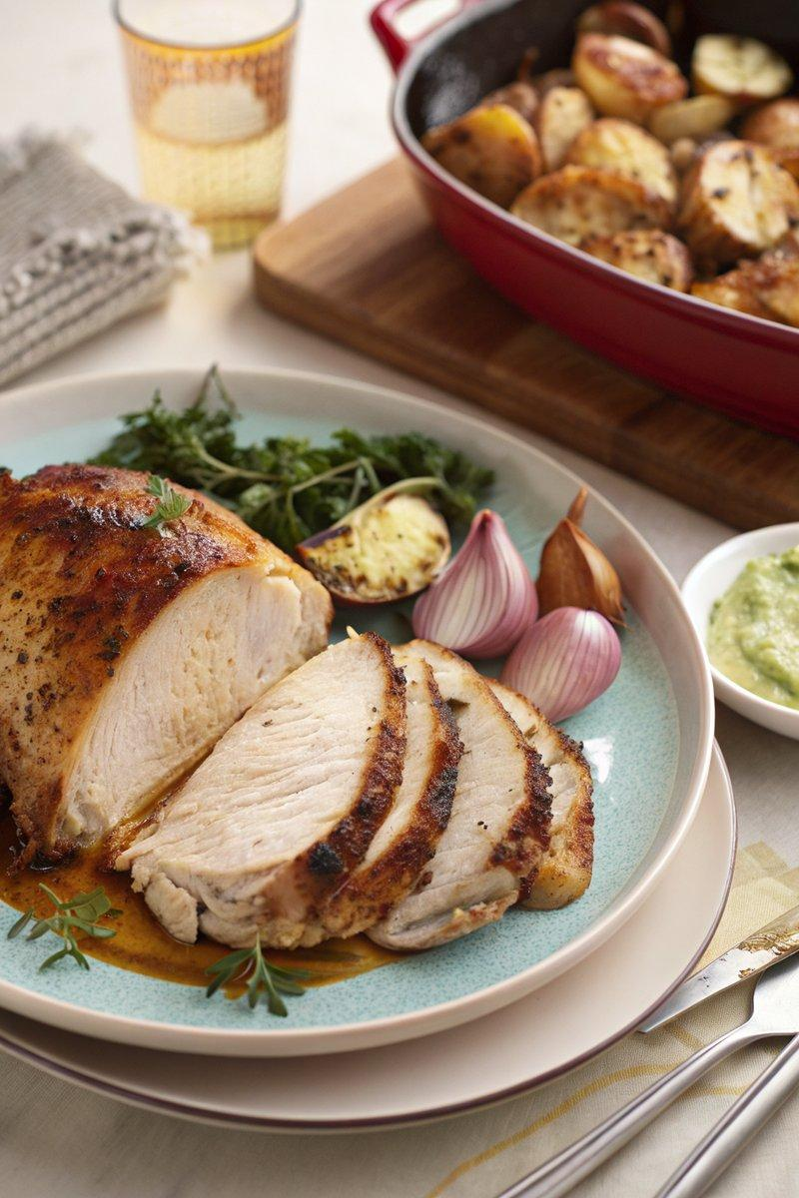

INGREDIENTS  - {'group': 'Main', 'item': '1.5-2kg turkey breast with skin'}  - {'group': 'Main', 'item': '1 large onion, peeled and quartered'}  - {'group': 'Main', 'item': '1 garlic bulb, halved horizontally'}  - {'group': 'Main', 'item': '200ml chicken stock'}  - {'group': 'Flavoured Butter', 'item': '200g butter, softened'}  - {'group': 'Flavoured Butter', 'item': '1 lemon, zested'}  - {'group': 'Flavoured Butter', 'item': '1 orange, zested'}  - {'group': 'Flavoured Butter', 'item': '1½ tsp garlic granules'}  - {'group': 'Flavoured Butter', 'item': '1 tsp smoked paprika'}  - {'group': 'Flavoured Butter', 'item': '3-4 rosemary sprigs, leaves chopped'}  - {'group': 'Flavoured Butter', 'item': '3-4 thyme sprigs, leaves chopped'}  - {'group': 'Flavoured Butter', 'item': '3-4 sage sprigs, leaves chopped'}  - {'group': 'Flavoured Butter', 'item': 'Salt and black pepper'} | PREP  In a small bowl, combine the softened butter with lemon zest, orange zest, garlic granules, smoked paprika, chopped rosemary, thyme, and sage. Season with salt and pepper. Carefully separate the turkey skin from the flesh to create a pocket and spread the flavoured butter evenly under the skin.  COOK  Place the quartered onion and halved garlic bulb in the bottom of the slow cooker. Position the turkey breast on top and pour the chicken stock around it. Cover and cook on low for 4½ hours, or until the internal temperature reaches 70°C (158°F (70°C)). Allow the turkey to rest with the lid on for 15-20 minutes.  PLATING  Preheat the grill to high. Transfer the turkey to an oven-safe dish if necessary and grill until the skin is golden and crisp. Carve the turkey and serve with the prepared sides.

NOTES:
For a delicious gravy, strain the cooking juices and squeeze out the garlic cloves. Melt 50g of butter in a saucepan, add 2 tbsp of plain flour, and cook until smooth. Gradually whisk in the hot turkey stock until thickened. Season with salt and pepper.

