SLOW-COOKED MUSHROOM RISOTTO  COOK TIME: 2 hrs  SOURCE: Unknown  #vegetarian #Italian #slow-cook | 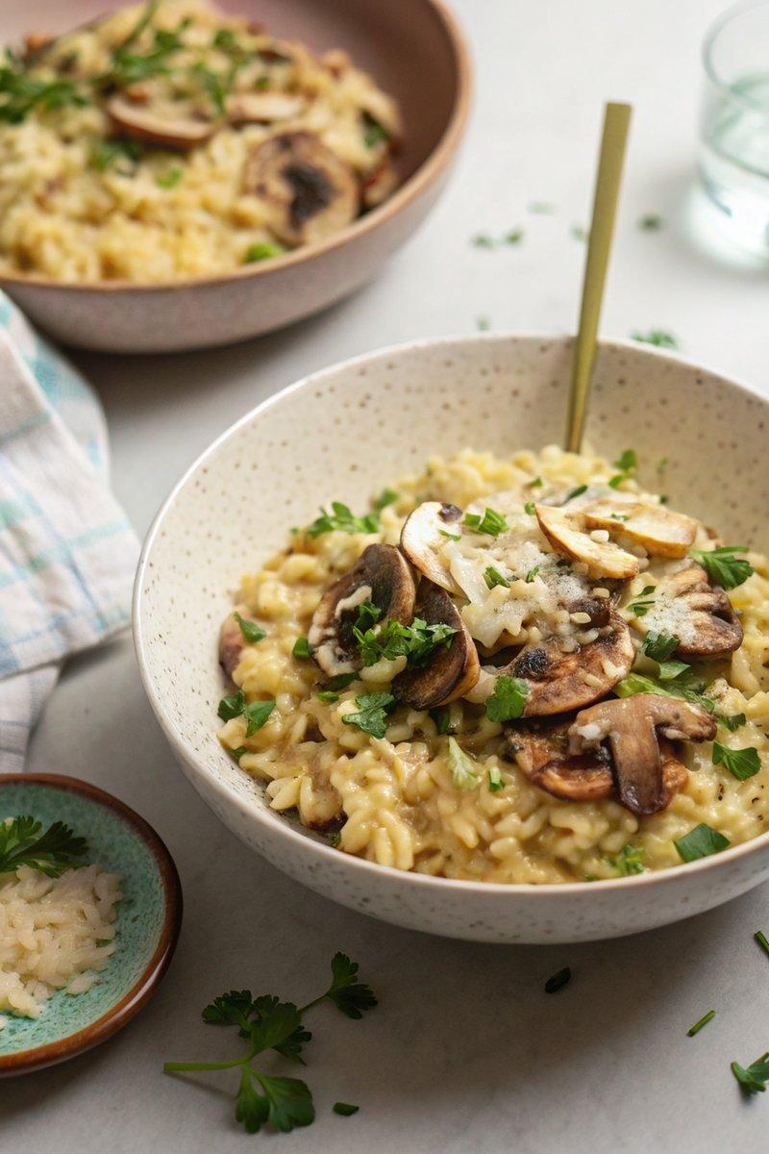

INGREDIENTS  - {'group': 'Main', 'item': '300g risotto rice'}  - {'group': 'Main', 'item': '2 leeks, thinly sliced'}  - {'group': 'Main', 'item': '3 garlic cloves, grated or crushed'}  - {'group': 'Main', 'item': '300g mixed mushrooms, sliced (chestnut, shiitake, oyster)'}  - {'group': 'Main', 'item': '200ml white wine'}  - {'group': 'Main', 'item': '450ml vegetable stock'}  - {'group': 'Main', 'item': '200g frozen peas, defrosted'}  - {'group': 'Main', 'item': '80g parmesan, grated, plus extra to serve'}  - {'group': 'Main', 'item': 'knob of butter'}  - {'group': 'Seasoning', 'item': 'salt and black pepper'}  - {'group': 'Garnish', 'item': 'flat-leaf parsley, roughly chopped (optional)'} | PREP  Thinly slice the leeks and mushrooms. Grate or crush the garlic cloves. Defrost the peas if frozen.  COOK  Combine the risotto rice, leeks, garlic, mushrooms, white wine, and vegetable stock in the slow cooker. Season with 1 tsp of salt and a generous amount of black pepper. Stir to mix. Cook on low for 2 hours, stirring occasionally, until the rice is al dente and the liquid is absorbed. Stir in the peas, then mix in the parmesan and butter until the risotto is creamy. Adjust seasoning if necessary.  PLATING  Divide the risotto among four plates. Top with extra grated parmesan and a crack of black pepper. Garnish with chopped parsley if desired.

NOTES:
For added flavour, finish with a grating of lemon zest. For a non-vegetarian option, top with sliced and fried chorizo.

