MEDITERRANEAN PUTTANESCA PASTA  COOK TIME: 4 hrs 30 mins  SOURCE: Unknown  #vegetarian #Mediterranean #slow-cook | 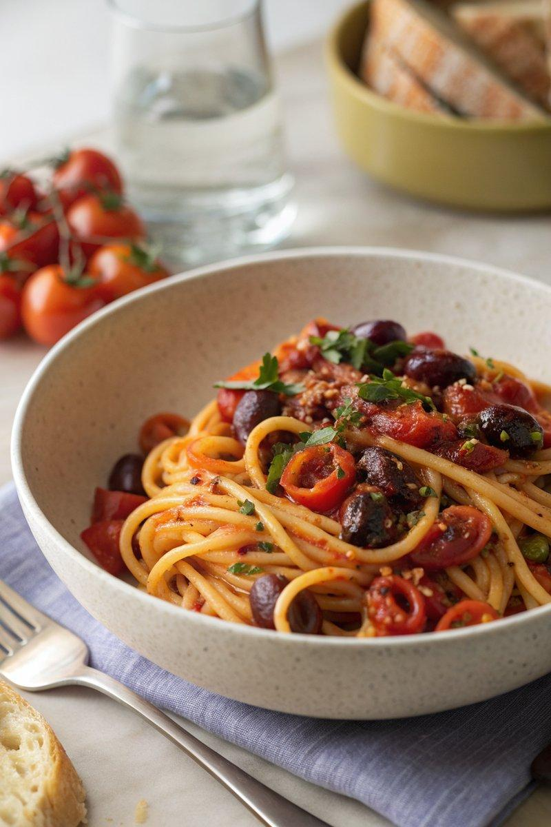

INGREDIENTS  - {'group': 'Main', 'item': '4 garlic cloves, grated or crushed'}  - {'group': 'Main', 'item': '1 red onion, finely diced'}  - {'group': 'Main', 'item': '2 x 400g cans of cherry tomatoes'}  - {'group': 'Main', 'item': '4 tbsp capers, drained'}  - {'group': 'Main', 'item': '165g pitted kalamata olives'}  - {'group': 'Main', 'item': '1 tbsp tomato purée'}  - {'group': 'Main', 'item': '½ tsp white sugar'}  - {'group': 'Main', 'item': '1 tsp chilli flakes'}  - {'group': 'Main', 'item': '300g spaghetti or penne'}  - {'group': 'Garnish', 'item': 'Small handful flat-leaf parsley, roughly chopped'}  - {'group': 'Garnish', 'item': 'Olive oil'}  - {'group': 'Seasoning', 'item': 'Salt and black pepper'} | PREP  Grate or crush the garlic cloves and finely dice the red onion. Drain the capers and pit the kalamata olives if necessary. Roughly chop the parsley leaves.  COOK  In the slow cooker, combine the garlic, onion, cherry tomatoes, capers, olives, tomato purée, sugar, chilli flakes, and ½ tsp of salt. Season with pepper and add a can of water. Cover and cook on high for 4 hours, stirring occasionally. After 4 hours, add the spaghetti or penne, ensuring it is submerged in the sauce. Cook for an additional 25-30 mins on high until the pasta is al dente.  PLATING  Stir in most of the parsley and a splash of olive oil until the sauce is glossy. Divide the pasta among four bowls, drizzle with more olive oil, crack over some black pepper, and scatter the remaining parsley on top.

NOTES:
For a non-vegetarian option, consider adding a can of anchovies for extra saltiness. Serve with Mediterranean garlic bread for a complete meal.

