SPICY TOFU AND CHICKPEA CURRY  COOK TIME: 3 hours on high or 6 hours on low  SOURCE: Unknown  #tofu #asian #slow-cook | 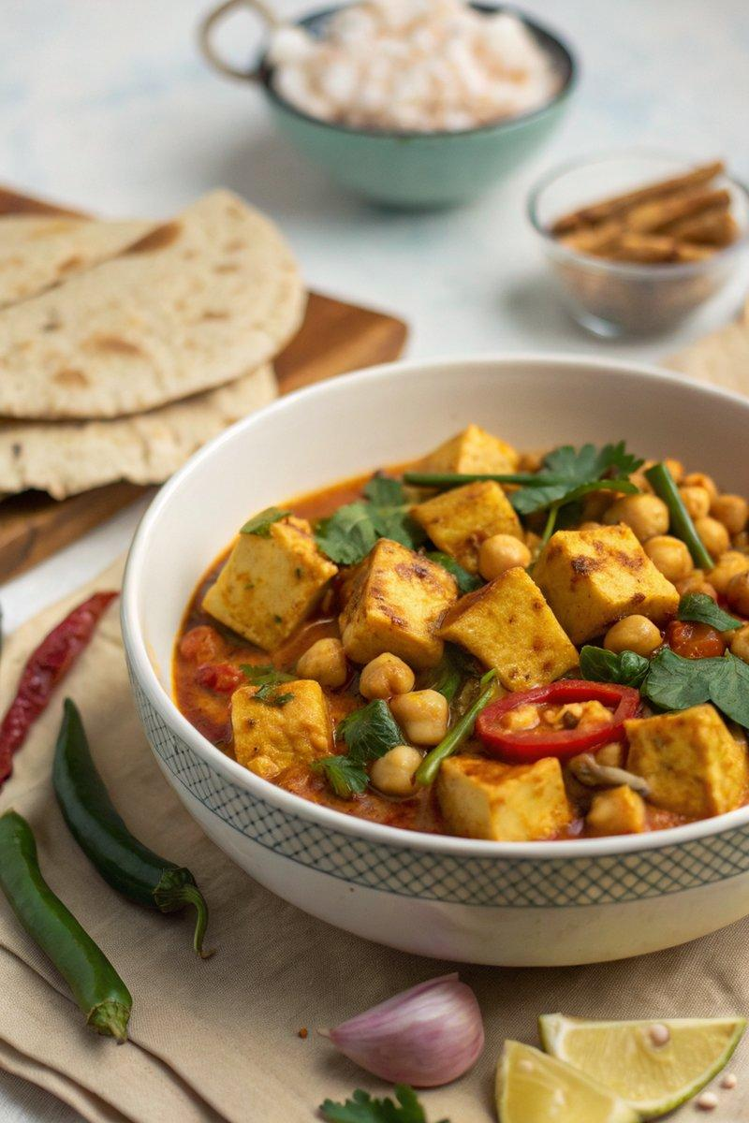

INGREDIENTS  - {'group': 'Main', 'item': '280g firm tofu, drained and cut into 2cm dice'}  - {'group': 'Main', 'item': '3 garlic cloves, grated or crushed'}  - {'group': 'Main', 'item': 'small thumb-sized piece of ginger, peeled and grated'}  - {'group': 'Main', 'item': '20 fresh curry leaves'}  - {'group': 'Main', 'item': '400ml full-fat coconut milk'}  - {'group': 'Main', 'item': '1 x 400g can of chickpeas, drained'}  - {'group': 'Main', 'item': '500g cherry tomatoes'}  - {'group': 'Seasoning', 'item': '2 tsp garam masala'}  - {'group': 'Seasoning', 'item': '½ tsp ground turmeric'}  - {'group': 'Seasoning', 'item': 'pinch of dried chilli flakes, to taste'}  - {'group': 'Seasoning', 'item': '1 vegetable stock cube, crumbled'}  - {'group': 'Main', 'item': '80g sugar snap peas'}  - {'group': 'Garnish', 'item': '3 tbsp natural yoghurt'}  - {'group': 'Seasoning', 'item': 'salt and black pepper'} | PREP  Drain and dice the tofu into 2cm cubes. Grate the garlic and ginger. Prepare the curry leaves and measure out the coconut milk, chickpeas, and cherry tomatoes.  COOK  Combine the tofu, garlic, ginger, curry leaves, coconut milk, chickpeas, tomatoes, garam masala, turmeric, chilli flakes, and crumbled stock cube in the slow cooker. Season with 1 tsp of salt and pepper. Stir well, cover, and cook on high for 2½ hours or on low for 5½ hours. Add the sugar snap peas and cook for an additional 30 minutes until tender and fragrant.  PLATING  Divide the curry into four bowls. Serve with steamed rice or flatbreads and poppadoms, topped with a dollop of natural yoghurt.

NOTES:
Use full-fat coconut milk for a richer texture. Adjust seasoning with lime juice if desired.

