PEANUT SATAY SWEET POTATO CURRY  COOK TIME: 2-3 hrs on high or 6 hrs on low  SOURCE: Unknown  #vegetarian #asian #slow-cook | 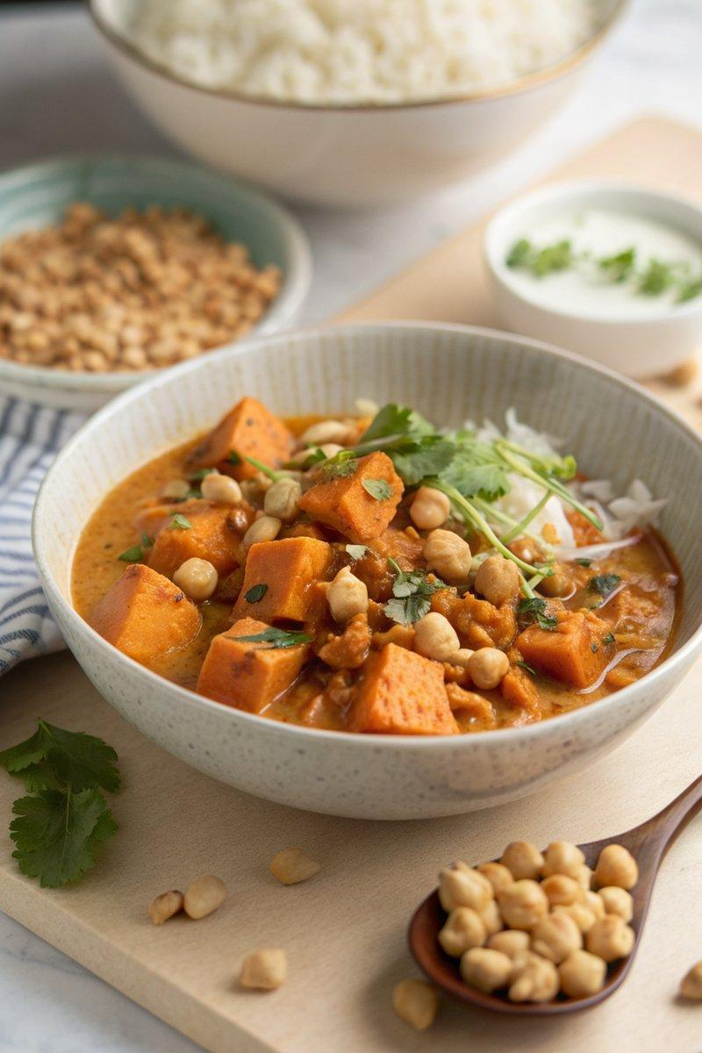

INGREDIENTS  - {'group': 'Main', 'item': '2 sweet potatoes, peeled and cut into 2cm dice'}  - {'group': 'Main', 'item': '4 garlic cloves, crushed'}  - {'group': 'Main', 'item': '1 x 400g can of chickpeas, drained'}  - {'group': 'Main', 'item': '400ml full-fat coconut milk'}  - {'group': 'Main', 'item': '150g peanut butter'}  - {'group': 'Main', 'item': '150g kale, stems removed and sliced'}  - {'group': 'Sauce', 'item': '1 vegetable stock cube dissolved in 200ml boiling water'}  - {'group': 'Sauce', 'item': '2 tbsp runny honey'}  - {'group': 'Sauce', 'item': '2 tbsp dark soy sauce'}  - {'group': 'Sauce', 'item': '2 tsp mild curry powder'}  - {'group': 'Sauce', 'item': '1/2 tsp ground turmeric'}  - {'group': 'Seasoning', 'item': 'Salt and black pepper'}  - {'group': 'Garnish', 'item': '1 lime, zested and juiced'}  - {'group': 'Garnish', 'item': 'Thumb-sized piece of ginger, peeled and julienned'}  - {'group': 'Garnish', 'item': '4 spring onions, sliced'}  - {'group': 'Garnish', 'item': 'Handful of coriander leaves, chopped'}  - {'group': 'Garnish', 'item': '2 red chillies, deseeded and thinly sliced'} | PREP  Dissolve the vegetable stock cube in 200ml boiling water. Peel and dice the sweet potatoes into 2cm cubes. Crush the garlic cloves. Drain the chickpeas. Remove stems from the kale and slice the leaves.  COOK  In a slow cooker, combine the dissolved stock, sweet potatoes, garlic, chickpeas, coconut milk, peanut butter, honey, soy sauce, curry powder, turmeric, salt, and pepper. Stir well. Cook on high for 2-3 hours or on low for 6 hours until the sweet potatoes are tender. Stir in the kale during the last 15 minutes of cooking.  PLATING  Divide the curry into four bowls. Garnish with lime zest and juice, julienned ginger, sliced spring onions, chopped coriander leaves, and sliced chillies. Serve with steamed white rice.

NOTES:
For added crunch, roast salted peanuts with curry powder and sprinkle over the curry before serving.

