TOMATO AND SPINACH LENTIL DAHL  COOK TIME: 2 hrs  SOURCE: Unknown  #lentils #Indian #slow-cook | 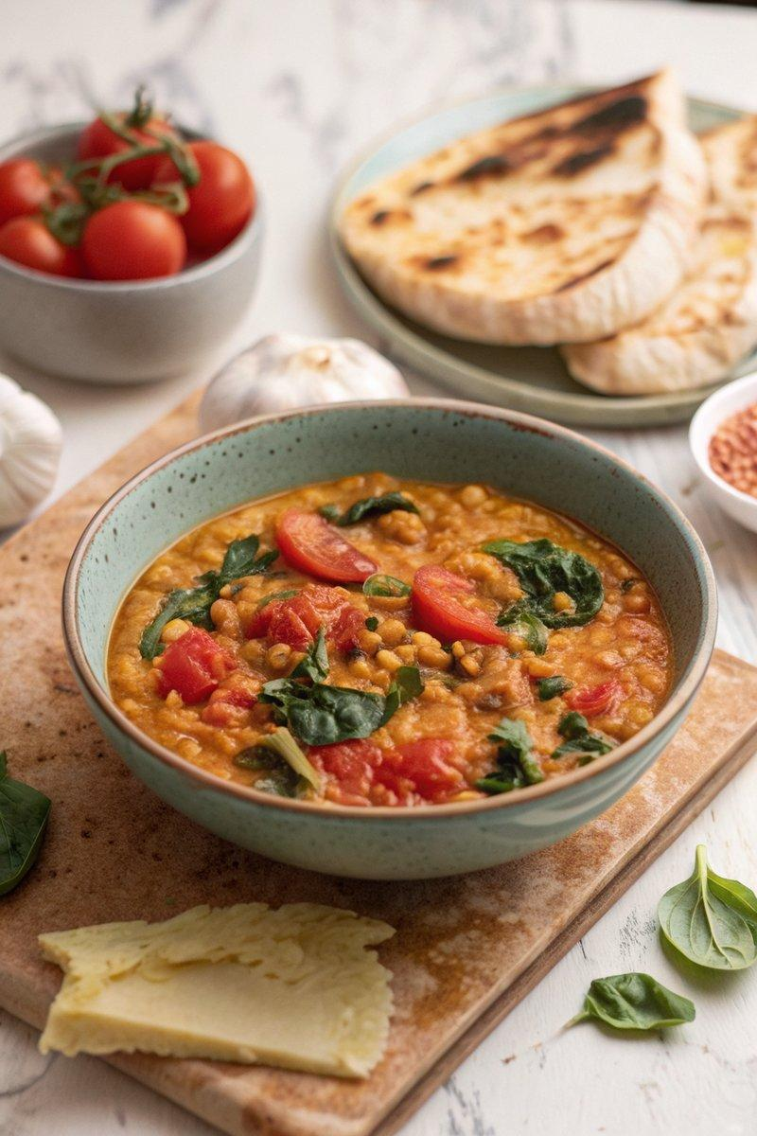

INGREDIENTS  - {'group': 'Main', 'item': '300g red lentils, rinsed'}  - {'group': 'Main', 'item': '2 onions, finely diced'}  - {'group': 'Main', 'item': '2 garlic cloves, grated or crushed'}  - {'group': 'Main', 'item': 'small thumb-sized piece of ginger, peeled and grated'}  - {'group': 'Main', 'item': '2 finger chillies, slit lengthways (optional)'}  - {'group': 'Main', 'item': '1 bay leaf'}  - {'group': 'Main', 'item': '½ tsp ground turmeric'}  - {'group': 'Main', 'item': '1 tsp cumin seeds'}  - {'group': 'Main', 'item': '900ml vegetable stock, plus extra if needed'}  - {'group': 'Main', 'item': '2 plum tomatoes, seeds removed and flesh diced'}  - {'group': 'Main', 'item': '2 large handfuls of spinach'}  - {'group': 'Main', 'item': '1 lemon, juiced'}  - {'group': 'Main', 'item': 'splash of olive oil'}  - {'group': 'Main', 'item': 'salt'} | PREP  Rinse the red lentils thoroughly. Finely dice the onions and grate or crush the garlic. Peel and grate the ginger. Slit the chillies lengthways if using. Dice the tomatoes after removing the seeds.  COOK  In a slow cooker, combine the red lentils, onions, garlic, ginger, chillies, bay leaf, turmeric, cumin seeds, and vegetable stock. Season with 1 tsp of salt. Cover and cook on high for 2 hours, stirring occasionally. Once cooked, stir in the diced tomatoes and spinach, allowing the spinach to wilt. Add the lemon juice and a splash of olive oil, then adjust seasoning with additional salt if needed. For a looser consistency, stir in more stock as desired.  PLATING  Serve the dahl hot, accompanied by Indian flatbreads for dipping.

NOTES:
This dish can be served as a main course or as a side to other Indian curries. Adjust the spice level by adding or omitting the chillies.

