VEGAN LENTIL AND BEAN BOLOGNESE  COOK TIME: 6 hrs  SOURCE: Unknown  #vegan #Italian #slow-cook | 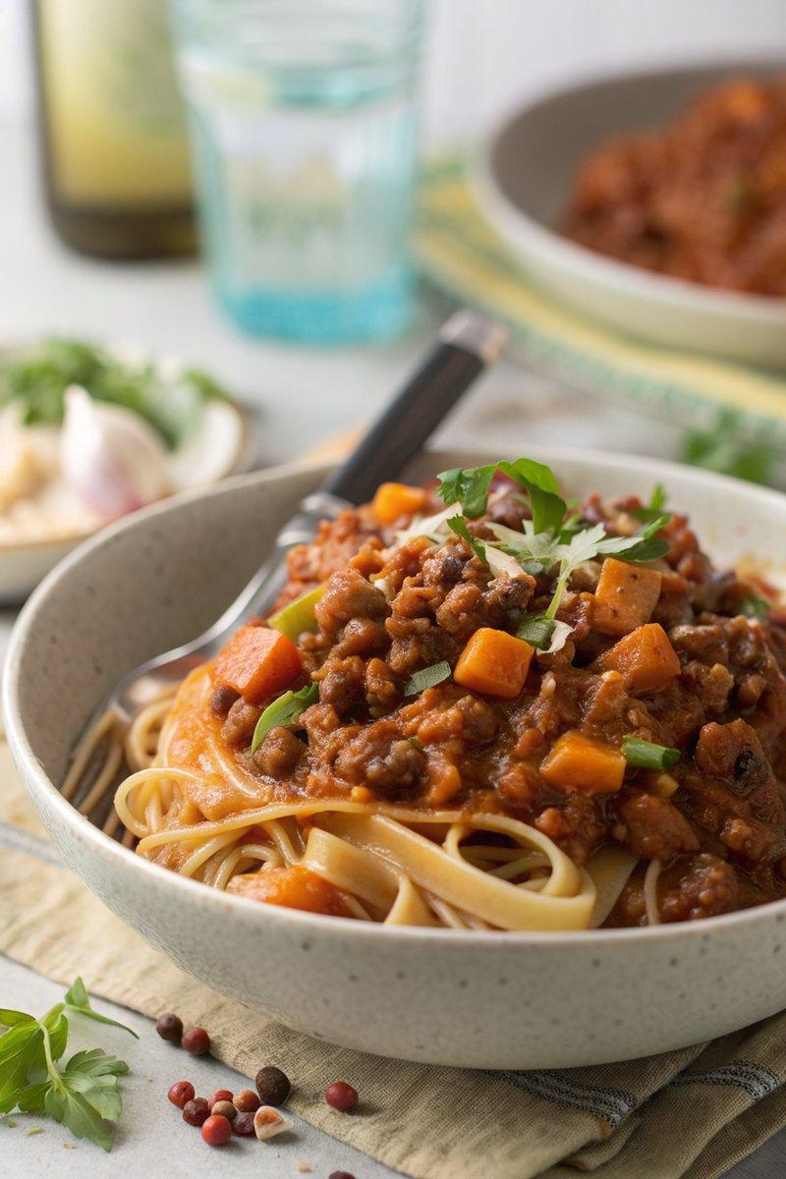

INGREDIENTS  - {'group': 'Main', 'item': '1 vegetable stock cube'}  - {'group': 'Main', 'item': '200 ml boiling water'}  - {'group': 'Main', 'item': '1 onion, finely diced'}  - {'group': 'Main', 'item': '2 carrots, finely diced'}  - {'group': 'Main', 'item': '2 celery sticks, finely diced'}  - {'group': 'Main', 'item': '4 garlic cloves, crushed'}  - {'group': 'Main', 'item': '2 bay leaves'}  - {'group': 'Main', 'item': '1 tbsp tomato purée'}  - {'group': 'Main', 'item': '1 tbsp red miso paste'}  - {'group': 'Main', 'item': '½ tsp white sugar'}  - {'group': 'Main', 'item': '400g can chopped tomatoes'}  - {'group': 'Main', 'item': '400g can green lentils, drained'}  - {'group': 'Main', 'item': '400g can butter beans, drained'}  - {'group': 'Main', 'item': '200 ml red wine'}  - {'group': 'Main', 'item': 'Grating of nutmeg (optional)'}  - {'group': 'Main', 'item': 'Splash of olive oil (optional)'}  - {'group': 'Main', 'item': 'Salt and black pepper'}  - {'group': 'For Serving', 'item': '300g pasta, cooked to packet instructions'}  - {'group': 'For Serving', 'item': 'Grated parmesan'} | PREP  Dissolve the vegetable stock cube in 200 ml of boiling water. Finely dice the onion, carrots, and celery. Crush the garlic cloves.  COOK  In a slow cooker, combine the dissolved stock, onion, carrots, celery, garlic, bay leaves, tomato purée, miso paste, sugar, chopped tomatoes, lentils, butter beans, and red wine. Season with 1 tsp of salt and plenty of black pepper. Cover and cook on high for 6 hours until the mixture is rich and tender. Adjust seasoning to taste.  PLATING  Serve the bolognese over cooked pasta, topped with grated parmesan and a drizzle of extra-virgin olive oil.

NOTES:
For an alcohol-free version, substitute the red wine with dark vegetable or mushroom stock to maintain the umami flavour.

