VEGETARIAN CHILLI WITH DARK CHOCOLATE  COOK TIME: 4 hrs  SOURCE: Unknown  #vegetarian #Mexican #slow-cook | 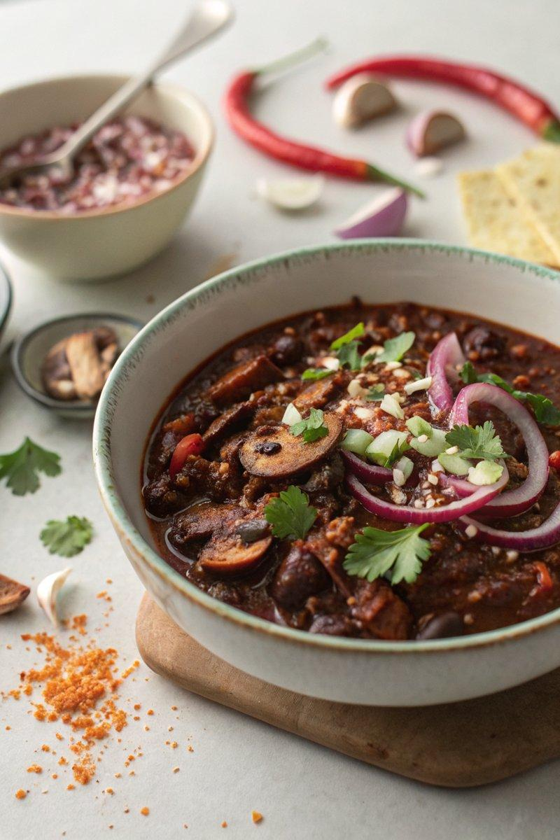

INGREDIENTS  - {'group': 'Main', 'item': '1 red onion, sliced'}  - {'group': 'Main', 'item': '300g closed-cup mushrooms, roughly chopped'}  - {'group': 'Main', 'item': '4 garlic cloves, grated or crushed'}  - {'group': 'Main', 'item': '2 bay leaves'}  - {'group': 'Seasoning', 'item': '2 tsp ground cumin'}  - {'group': 'Seasoning', 'item': '2 tsp smoked paprika'}  - {'group': 'Seasoning', 'item': '2 tbsp chipotle paste'}  - {'group': 'Seasoning', 'item': '1 tsp chilli flakes'}  - {'group': 'Sauce', 'item': '2 tbsp tomato purée'}  - {'group': 'Sauce', 'item': '1 tbsp red miso paste'}  - {'group': 'Sauce', 'item': '1 tsp dark brown soft sugar'}  - {'group': 'Sauce', 'item': '1 vegetable stock cube, crumbled'}  - {'group': 'Sauce', 'item': '1 x 400g can of plum tomatoes'}  - {'group': 'Main', 'item': '2 x 400g cans of butter beans, drained'}  - {'group': 'Sauce', 'item': '150ml strong black coffee'}  - {'group': 'Optional', 'item': '20g 70% dark chocolate'}  - {'group': 'Garnish', 'item': 'large handful of coriander, leaves roughly chopped'}  - {'group': 'Seasoning', 'item': 'salt and black pepper'} | PREP  Slice the red onion and roughly chop the mushrooms. Grate or crush the garlic cloves.  COOK  Combine the red onion, mushrooms, garlic, bay leaves, cumin, smoked paprika, chipotle paste, chilli flakes, tomato purée, red miso paste, dark brown sugar, crumbled vegetable stock cube, plum tomatoes, butter beans, and black coffee in a slow cooker. Season with 1 tsp of salt and plenty of black pepper. Cover and cook on high for 4 hours until the mixture is rich and tender. Stir in the dark chocolate, if using, and adjust seasoning as needed.  PLATING  Serve the chilli hot, garnished with chopped coriander. Pair with steamed rice, warmed tortillas, or use as a filling for tacos.

NOTES:
Dark chocolate adds depth to the chilli without overpowering it. Feel free to substitute butter beans with kidney beans if preferred.

