SLOW-COOKED VEGGIE FAJITAS  COOK TIME: 4 hrs 5 mins  SOURCE: Unknown  #vegetarian #Mexican #slow-cook | 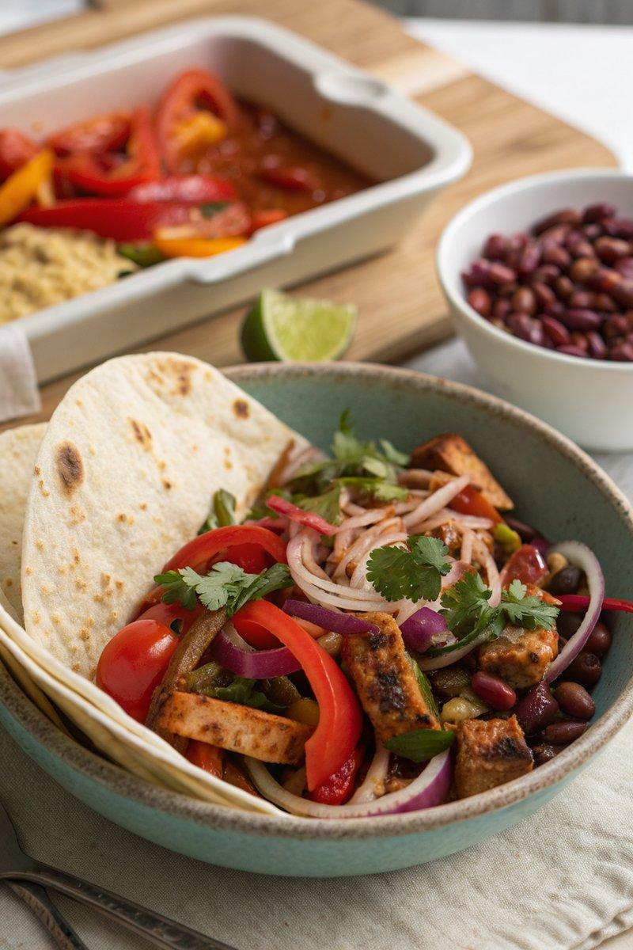

INGREDIENTS  - {'group': 'Main', 'item': '4 red peppers, deseeded and thinly sliced'}  - {'group': 'Main', 'item': '2 red onions, thinly sliced'}  - {'group': 'Main', 'item': '6 garlic cloves, grated or crushed'}  - {'group': 'Main', 'item': '2x 280g blocks of firm tofu, drained and cut into 1cm dice'}  - {'group': 'Main', 'item': '2x 400g cans of kidney beans, drained'}  - {'group': 'Sauce', 'item': '1 tbsp tomato purée'}  - {'group': 'Sauce', 'item': '1 tsp ground coriander'}  - {'group': 'Sauce', 'item': '1-2 tsp cayenne pepper'}  - {'group': 'Sauce', 'item': '2 tsp smoked paprika'}  - {'group': 'Sauce', 'item': '1 tsp ground cumin'}  - {'group': 'Sauce', 'item': '2 tsp chilli sauce'}  - {'group': 'Main', 'item': '200g baby spinach'}  - {'group': 'Seasoning', 'item': 'Salt and black pepper'}  - {'group': 'For Serving', 'item': '4-8 tortillas, warmed'}  - {'group': 'For Serving', 'item': 'Soured cream'}  - {'group': 'For Serving', 'item': 'Lime wedges'}  - {'group': 'For Serving', 'item': 'Grated cheddar'}  - {'group': 'For Serving', 'item': 'Thinly sliced red chilli'} | PREP  Prepare the vegetables by slicing the red peppers and red onions thinly. Grate or crush the garlic cloves. Drain and dice the tofu into 1cm cubes. Drain the kidney beans.  COOK  In a slow cooker, combine the sliced peppers, onions, garlic, diced tofu, and drained kidney beans. Add the tomato purée, ground coriander, cayenne pepper, smoked paprika, ground cumin, and chilli sauce. Season with 1 tsp of salt and plenty of black pepper. Stir well to combine. Cover and cook on high for 4 hours until the vegetables are tender. Add the baby spinach on top, cover again, and cook for an additional 5 minutes until wilted. Stir the spinach into the mixture and adjust seasoning if necessary.  PLATING  Serve the veggie fajita mixture with warmed tortillas, allowing each person to assemble their own fajitas. Offer soured cream, lime wedges, grated cheddar, and thinly sliced red chilli as toppings. Pair with zingy slaw and guacamole for a complete meal.

NOTES:
For a quick lunch option, pack the veggie filling with some rice and cheddar in a lunch box and reheat in a microwave.

