SLOW-COOKED VEGGIE TACOS  COOK TIME: 4 hrs  SOURCE: Unknown  #vegetarian #Mexican #slow-cook | 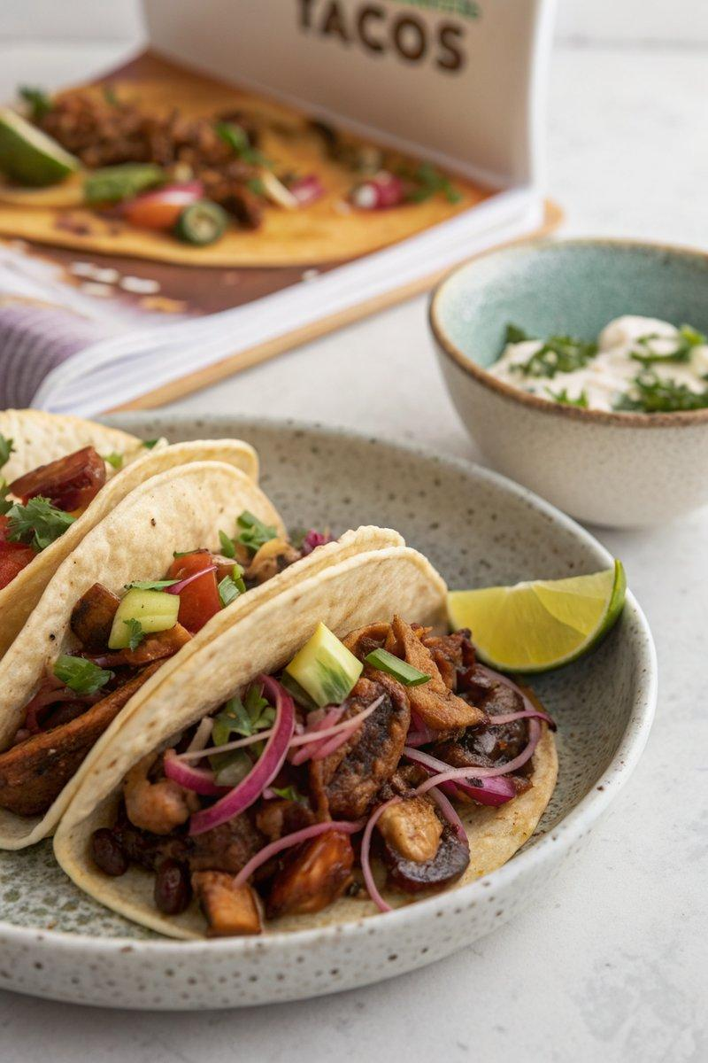

INGREDIENTS  - {'group': 'Main', 'item': '800g chestnut mushrooms, halved'}  - {'group': 'Main', 'item': '400g shallots, thinly sliced'}  - {'group': 'Main', 'item': '6 garlic cloves, grated or crushed'}  - {'group': 'Sauce', 'item': '2 tbsp white miso paste'}  - {'group': 'Sauce', 'item': '2 tbsp chipotle paste'}  - {'group': 'Seasoning', 'item': '1 tbsp chipotle chilli flakes or red chilli flakes'}  - {'group': 'Seasoning', 'item': '2 tsp coriander seeds, crushed'}  - {'group': 'Seasoning', 'item': '2 tsp cumin seeds'}  - {'group': 'Seasoning', 'item': '1 tsp salt'}  - {'group': 'Seasoning', 'item': 'Black pepper, to taste'}  - {'group': 'For Serving', 'item': '8 small corn tacos'} | PREP  Halve the chestnut mushrooms and thinly slice the shallots. Grate or crush the garlic cloves. Crush the coriander seeds.  COOK  Combine the mushrooms, shallots, garlic, miso paste, chipotle paste, chilli flakes, coriander seeds, cumin seeds, salt, and black pepper in the slow cooker. Stir well to mix all ingredients. Cover and cook on high for 4 hours until the mixture is rich and tender.  PLATING  Serve the mushroom mixture generously in the corn tacos. Optionally, accompany with a slaw made from shredded red cabbage, grated carrot, thinly sliced red onion, soured cream, mayonnaise, chopped chives, lime zest, and juice.

NOTES:
For a refreshing side, prepare a slaw with red cabbage, carrot, red onion, soured cream, mayonnaise, chives, lime zest, and juice.

