VEGETABLE AND BEAN HOTPOT  COOK TIME: 4 hrs 15 mins  SOURCE: Unknown  #vegetarian #British #slow-cook | 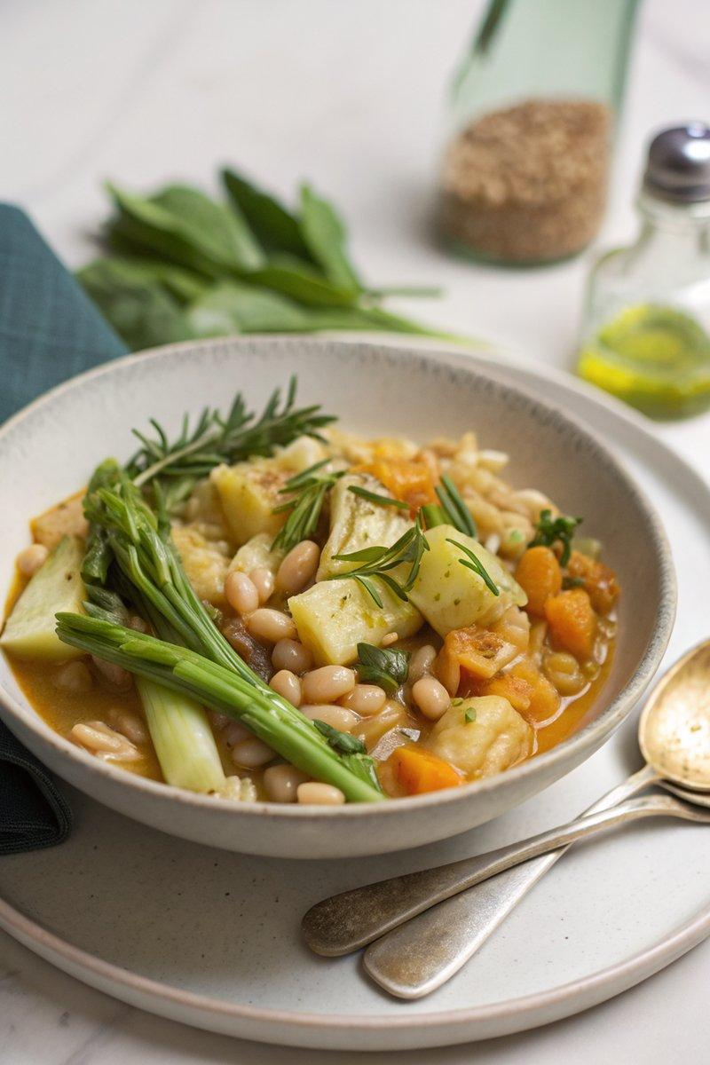

INGREDIENTS  - {'group': 'Main', 'item': '2 leeks, cut into 1cm slices'}  - {'group': 'Main', 'item': '1/2 celeriac, cut into 2cm dice'}  - {'group': 'Main', 'item': '2 rosemary sprigs, leaves picked'}  - {'group': 'Main', 'item': '400g can butter beans, drained'}  - {'group': 'Main', 'item': '3 tbsp pearl barley'}  - {'group': 'Main', 'item': '1 tsp fennel seeds'}  - {'group': 'Main', 'item': '1 tbsp white miso paste'}  - {'group': 'Main', 'item': 'pinch of chilli flakes (optional)'}  - {'group': 'Main', 'item': '1 vegetable stock cube, crumbled'}  - {'group': 'Main', 'item': '500g Maris Piper potatoes, cut into 5mm slices'}  - {'group': 'Main', 'item': 'olive oil'}  - {'group': 'Seasoning', 'item': 'salt and black pepper'} | PREP  Slice the leeks into 1cm pieces and dice the celeriac into 2cm cubes. Pick the rosemary leaves from the sprigs.  COOK  In the slow-cooker bowl, combine leeks, celeriac, rosemary, butter beans, pearl barley, fennel seeds, miso paste, chilli flakes, crumbled stock cube, 1/2 tsp salt, and black pepper. Stir well. Arrange potato slices on top in overlapping layers, starting from the outer edge. Sprinkle with salt, cover, and cook on high for 4 hours until potatoes are tender. Preheat the grill to high. Drizzle olive oil over the potatoes and grill for 10-15 mins until crisp and golden.  PLATING  Serve the hotpot with steamed green vegetables and a side of mustard for added flavour.

NOTES:
For an extra touch, sprinkle grated cheddar over the potatoes before grilling for a cheesy finish.

