SLOW-COOKED STUFFED PEPPERS WITH LENTILS AND PESTO  COOK TIME: 3 hrs  SOURCE: Unknown  #vegetarian #Mediterranean #slow-cook | 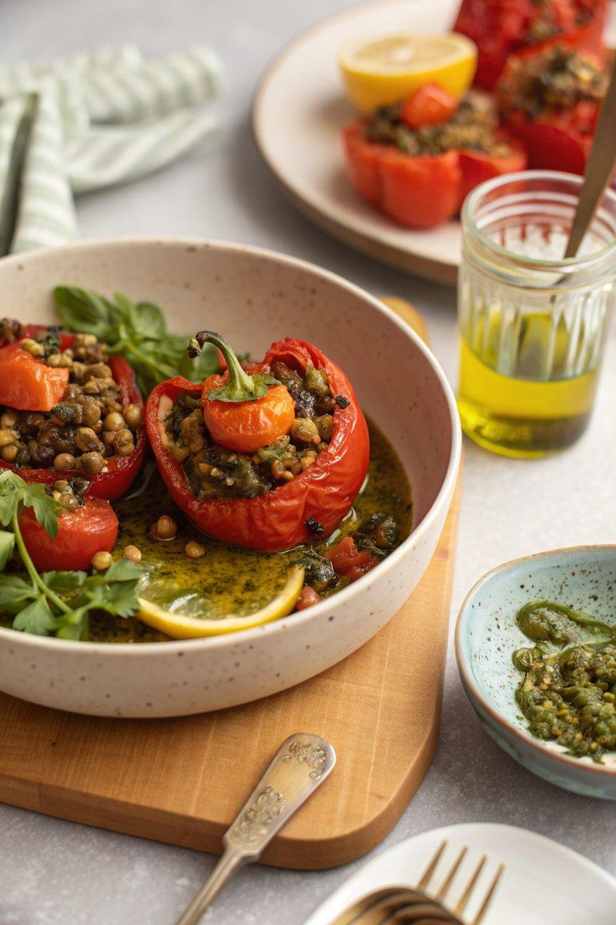

INGREDIENTS  - {'group': 'Main', 'item': '300g cherry tomatoes, roughly chopped'}  - {'group': 'Main', 'item': '500g cooked Puy lentils'}  - {'group': 'Main', 'item': '2 lemons, zested and juiced'}  - {'group': 'Main', 'item': '2-4 tbsp red or green pesto'}  - {'group': 'Main', 'item': 'pinch of chilli flakes (optional)'}  - {'group': 'Main', 'item': '3 tbsp extra-virgin olive oil, plus extra for drizzling'}  - {'group': 'Main', 'item': 'small handful of flat-leaf parsley, roughly chopped'}  - {'group': 'Main', 'item': '4-6 red peppers'}  - {'group': 'Garnish', 'item': '50g almonds, toasted and roughly chopped'}  - {'group': 'Garnish', 'item': 'small handful of basil, leaves roughly chopped'}  - {'group': 'Seasoning', 'item': 'sea-salt flakes and black pepper'} | PREP  Combine the cherry tomatoes, Puy lentils, lemon zest, pesto, chilli flakes, olive oil, and half of the parsley in a bowl. Season with sea-salt flakes and black pepper. Slice the tops off the red peppers and remove the seeds and pith.  COOK  Fill each pepper with the lentil mixture and replace the tops. Drizzle with olive oil and season the outside with sea-salt flakes. Place the peppers in the slow cooker, cover, and cook on high for 3 hours until tender but still holding their shape.  PLATING  Transfer the cooked peppers to serving plates. Drizzle with any juices from the slow cooker, sprinkle with toasted almonds, basil, remaining parsley, and a squeeze of lemon juice. Finish with a drizzle of extra-virgin olive oil.

NOTES:
These stuffed peppers can be reheated on a barbecue for a smoky flavour. They make a great vegetarian alternative at summer gatherings.

