CREAMY SLOW-COOKED MASHED POTATOES  COOK TIME: 4 hours on high or 7-8 hours on low  SOURCE: Unknown  #potatoes #American #slow-cook | 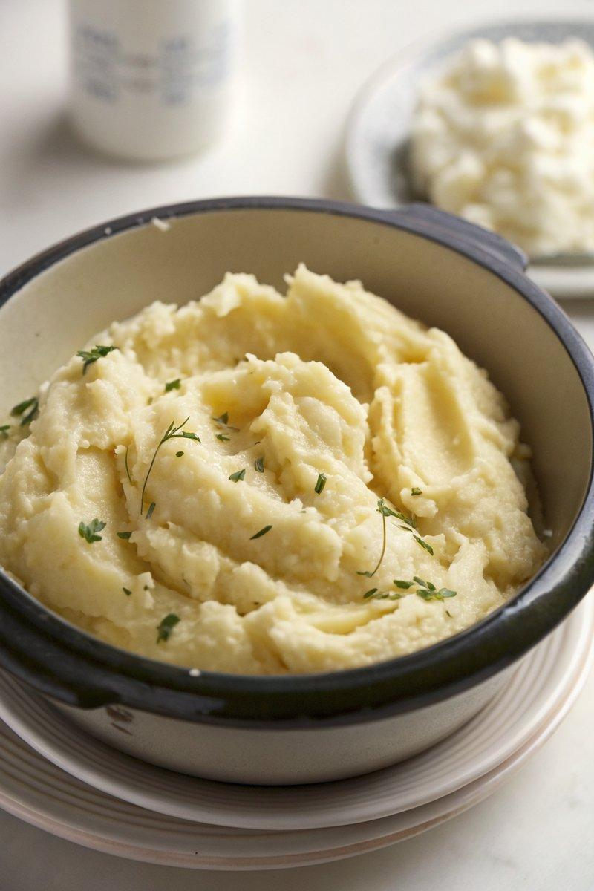

INGREDIENTS  - {'group': 'Main', 'item': '4 large Maris Piper potatoes, peeled and quartered'}  - {'group': 'Main', 'item': '150ml double cream'}  - {'group': 'Main', 'item': '100g salted butter, cubed'}  - {'group': 'Seasoning', 'item': '1 tsp salt'}  - {'group': 'Seasoning', 'item': 'Black pepper, to taste'} | PREP  Peel and quarter the Maris Piper potatoes.  COOK  Place the potatoes, double cream, and cubed butter into the slow cooker. Season with 1 tsp of salt and plenty of black pepper. Stir to combine. Cover and cook on high for 4 hours or on low for 7-8 hours, until the potatoes are completely tender.  PLATING  Once cooked, use a potato masher or balloon whisk to mash the potatoes until smooth and fluffy. Serve immediately or keep warm on low until ready to eat.

NOTES:
For a cheesy variation, stir in 200g of grated cheese after mashing.

