GARLIC BUTTER SLOW-COOKED POTATO CUBES  COOK TIME: 4-5 hrs on high or 7-8 hrs on low  SOURCE: Unknown  #potato #American #slow-cook | 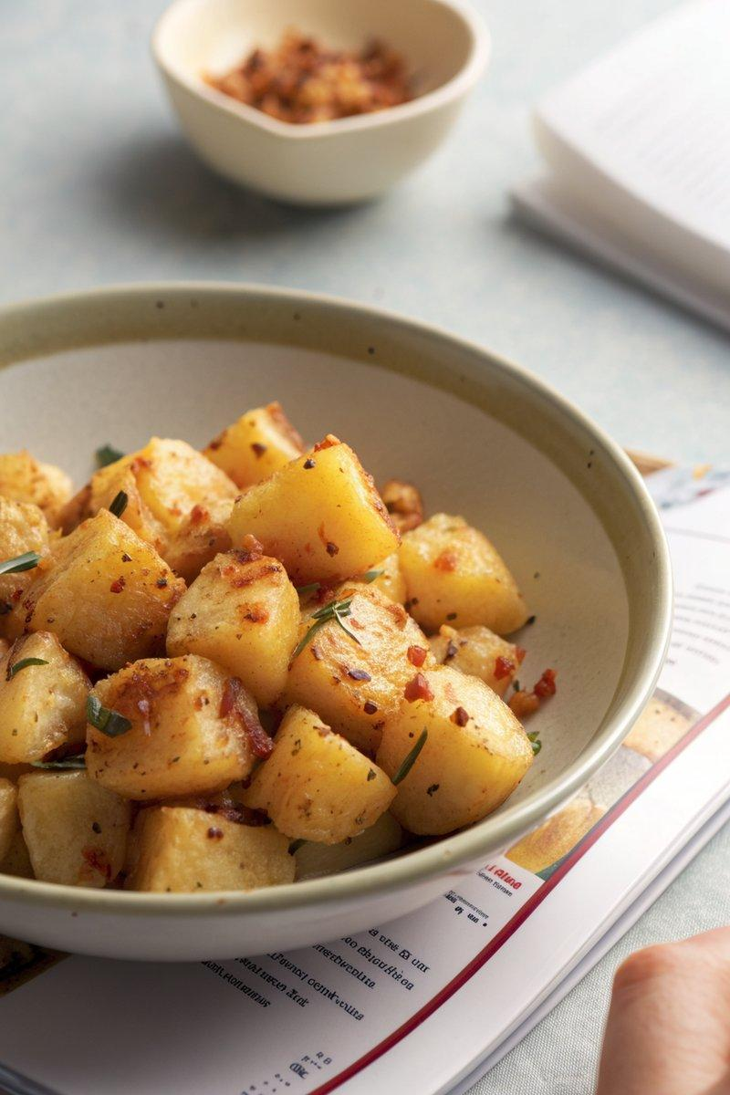

INGREDIENTS  - {'group': 'Main', 'item': '1kg King Edward potatoes, peeled and cut into 1cm cubes'}  - {'group': 'Main', 'item': '50g salted butter'}  - {'group': 'Main', 'item': '4 garlic cloves, grated'}  - {'group': 'Main', 'item': '1 tsp sweet paprika'}  - {'group': 'Main', 'item': '1 tsp chilli flakes'}  - {'group': 'Main', 'item': '50ml vegetable stock'}  - {'group': 'Main', 'item': 'Salt and black pepper to taste'}  - {'group': 'Optional', 'item': '1 tbsp runny honey'}  - {'group': 'Optional', 'item': '100g grated mozzarella'}  - {'group': 'Optional', 'item': '200g grated mature cheddar'} | PREP  Line the bowl of your slow cooker with foil. Peel and cube the potatoes into 1cm pieces. Grate the garlic cloves.  COOK  Place the potato cubes, butter, grated garlic, paprika, chilli flakes, and vegetable stock into the slow cooker. Season with salt and black pepper, then mix well to combine. Cover with the lid and cook on high for 4-5 hours or on low for 7-8 hours until the potatoes are tender. For a sweet variation, add honey during cooking. For a cheesy version, sprinkle mozzarella and cheddar over the potatoes in the last hour of cooking.  PLATING  Once cooked, serve the potatoes hot as a side dish. If using cheese, ensure it is melted and gooey before serving.

NOTES:
For a sweet twist, add honey for a sticky finish. To make it cheesy, add mozzarella and cheddar in the last hour of cooking.

