CREAMY SLOW-COOKED DAUPHINOISE POTATOES  COOK TIME: 3 hrs  SOURCE: Unknown  #potatoes #French #slow-cook | 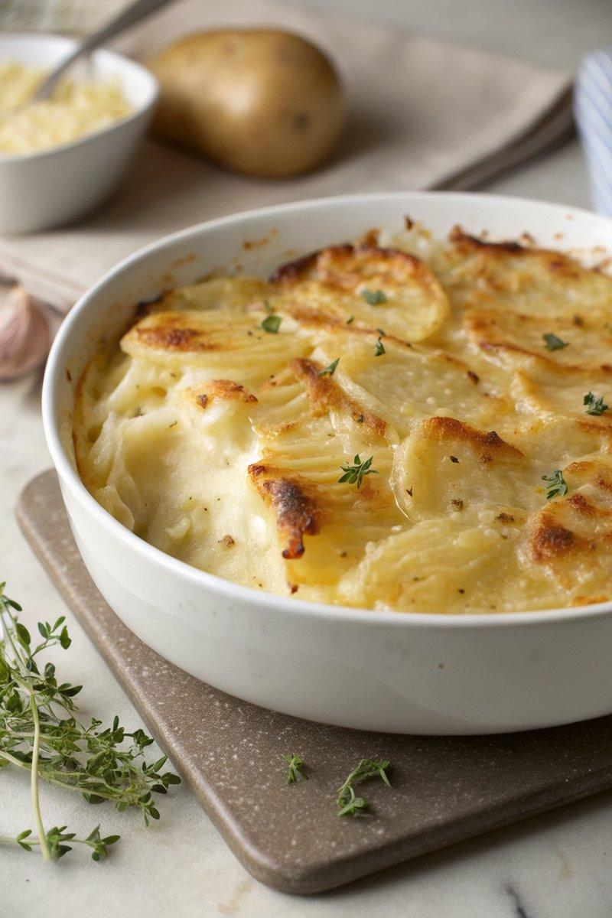

INGREDIENTS  - {'group': 'Main', 'item': '1.5kg King Edward potatoes, peeled and cut into 5mm slices'}  - {'group': 'Main', 'item': '6 garlic cloves, sliced'}  - {'group': 'Main', 'item': '600ml double cream'}  - {'group': 'Main', 'item': '2 thyme sprigs, leaves picked'}  - {'group': 'Topping', 'item': 'handful of grated extra-mature cheddar (optional)'}  - {'group': 'Seasoning', 'item': 'sea-salt flakes and black pepper'} | PREP  Peel and slice the King Edward potatoes into 5mm slices. Slice the garlic cloves and pick the thyme leaves.  COOK  Place the potato slices, garlic, double cream, thyme leaves, sea-salt flakes, and black pepper into the slow cooker. Mix well to ensure the potatoes are coated in cream. Flatten the potato slices, cover, and cook on high for 3 hours or on low for 6 hours until tender and the cream has thickened. For a crispy top, sprinkle grated cheddar over the potatoes and grill in an oven-safe slow cooker on medium heat for 5-10 mins until golden and bubbling.  PLATING  Serve the dauphinoise potatoes hot, directly from the slow cooker or transfer to a serving dish.

NOTES:
These potatoes pair well with pork chops, bacon-wrapped chicken, or any hearty main dish.

