CHOCOLATE AND MARSHMALLOW DIPPING BOWL  COOK TIME: 30 mins  SOURCE: Unknown  #chocolate #American #slow-cook | 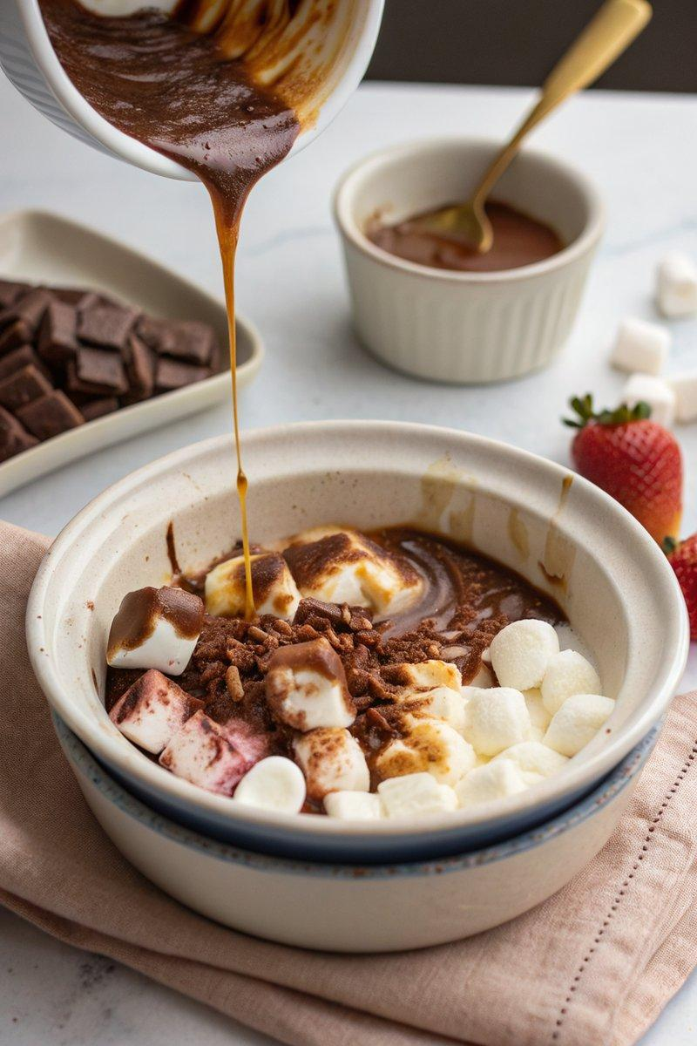

INGREDIENTS  - {'group': 'Main', 'item': '100g dark chocolate, roughly chopped'}  - {'group': 'Main', 'item': '100g milk chocolate, roughly chopped'}  - {'group': 'Main', 'item': '1 tbsp golden syrup'}  - {'group': 'Main', 'item': '200ml double cream'}  - {'group': 'Main', 'item': '1-2 tbsp crunchy peanut butter (optional)'}  - {'group': 'Main', 'item': 'big pinch of sea salt flakes'}  - {'group': 'Main', 'item': '200-400g marshmallows'}  - {'group': 'For Serving', 'item': '180g digestive biscuits'} | PREP  Roughly chop the dark and milk chocolate. Measure out the golden syrup, double cream, and peanut butter if using.  COOK  Combine the dark chocolate, milk chocolate, golden syrup, double cream, peanut butter, and sea salt in the bowl of a slow cooker. Stir well, cover, and cook on low for 30 minutes until melted and smooth. Preheat the grill to high if your slow cooker bowl is oven-safe. Once the chocolate mixture is ready, scatter marshmallows over the top. Transfer the bowl to the grill and cook for 5-10 minutes until the marshmallows are golden and bubbling. If not grill-safe, cover with a tea towel under the lid and cook for an additional 10-15 minutes until marshmallows are soft.  PLATING  Serve the chocolate and marshmallow dip warm with digestive biscuits for dipping.

NOTES:
For a twist, add orange zest or chilli flakes to the chocolate mixture. Serve with a glass of Baileys for an adult version.

