ORANGE CHOCOLATE BRIOCHE BREAD PUDDING  COOK TIME: 1 hour on high or 2 hours on low  SOURCE: Unknown  #chocolate #French #slow-cook | 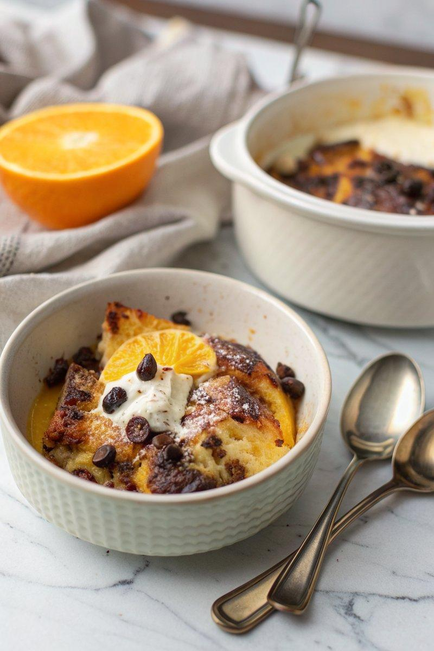

INGREDIENTS  - {'group': 'Custard', 'item': '4 egg yolks'}  - {'group': 'Custard', 'item': '65g golden caster sugar'}  - {'group': 'Custard', 'item': '1/4 tsp vanilla paste or seeds from 1 vanilla pod'}  - {'group': 'Custard', 'item': 'Zest of 1 large orange'}  - {'group': 'Custard', 'item': 'Small pinch of salt'}  - {'group': 'Custard', 'item': '330ml whole milk'}  - {'group': 'Custard', 'item': '330ml double cream'}  - {'group': 'Bread Pudding', 'item': '20g butter'}  - {'group': 'Bread Pudding', 'item': '300g day-old brioche, sliced'}  - {'group': 'Bread Pudding', 'item': '100g 70% dark chocolate, roughly chopped'}  - {'group': 'Bread Pudding', 'item': '1 tbsp demerara sugar'} | PREP  Whisk together the egg yolks, golden caster sugar, vanilla, orange zest, and salt until the sugar dissolves. Stir in the milk and cream to complete the custard. Generously butter the base and halfway up the sides of the slow-cooker bowl.  COOK  Layer half of the brioche slices in the slow-cooker, sprinkle with half of the chopped chocolate, and cover with the remaining brioche. Pour the custard evenly over the brioche layers, then scatter the remaining chocolate and demerara sugar on top. Cover the slow-cooker with a clean tea towel to absorb steam, secure the lid, and cook on high for 1 hour or on low for 2 hours until the pudding is set and golden.  PLATING  Serve the pudding warm, optionally accompanied by double cream, vanilla ice cream, or extra custard for added indulgence.

NOTES:
For a sweeter variation, substitute dark chocolate with milk or white chocolate, adjusting the sugar topping to taste.

