STEAMED TREACLE SPONGE PUDDING  COOK TIME: 2 hrs  SOURCE: Unknown  #dessert #British #steamed | 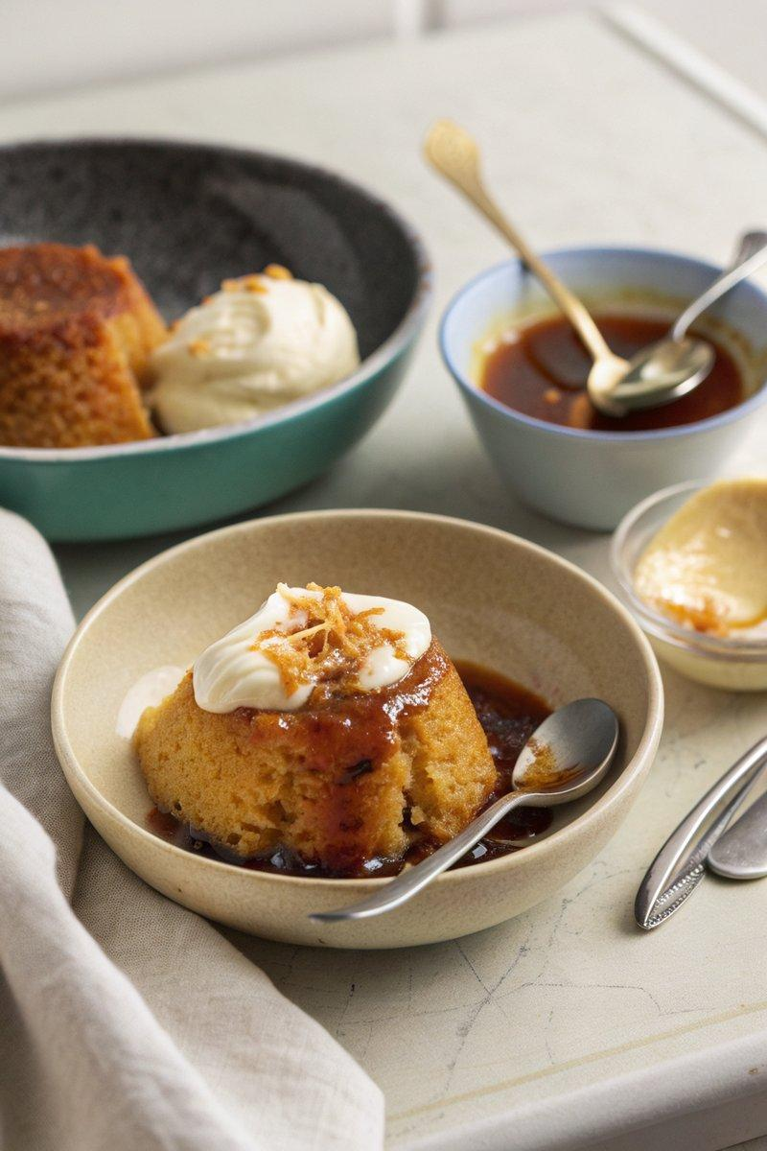

INGREDIENTS  - {'group': 'Main', 'item': '120g unsalted butter, cubed and at room temperature, plus extra for greasing'}  - {'group': 'Main', 'item': '120g golden caster sugar'}  - {'group': 'Main', 'item': '2 eggs'}  - {'group': 'Main', 'item': '120g self-raising flour, sifted'}  - {'group': 'Main', 'item': '2 tbsp whole milk'}  - {'group': 'Main', 'item': 'Pinch of salt'}  - {'group': 'Main', 'item': '1 lemon, zested'}  - {'group': 'Main', 'item': '3 tbsp golden syrup, plus extra to serve'}  - {'group': 'For Serving', 'item': 'Double cream'} | PREP  Grease a 1-litre pudding basin with butter and line the base with baking parchment. Set the slow cooker to high to preheat. In a stand mixer, cream the butter and sugar until light and fluffy. Beat in the eggs one at a time. Fold in the flour, then add the milk, salt, and lemon zest.  COOK  Spoon the golden syrup into the prepared basin, then add the batter, smoothing the top. Cover with baking parchment and foil, making a pleat for expansion. Secure with kitchen string. Place the basin in the slow cooker and pour boiling water halfway up the sides. Cover with a tea towel and lid. Cook on high for 2 hours until a skewer comes out clean.  PLATING  Let the pudding stand for 10 minutes. Remove the basin, loosen the sponge with a knife, and invert onto a plate. Serve with extra golden syrup and double cream.

NOTES:
For a fruity twist, add a spoonful of raspberry jam with the golden syrup, but balance the quantities to avoid a soggy texture.

