STICKY TOFFEE PUDDING WITH RICH TOFFEE SAUCE  COOK TIME: 2 hrs  SOURCE: Unknown  #dessert #British #slow-cook | 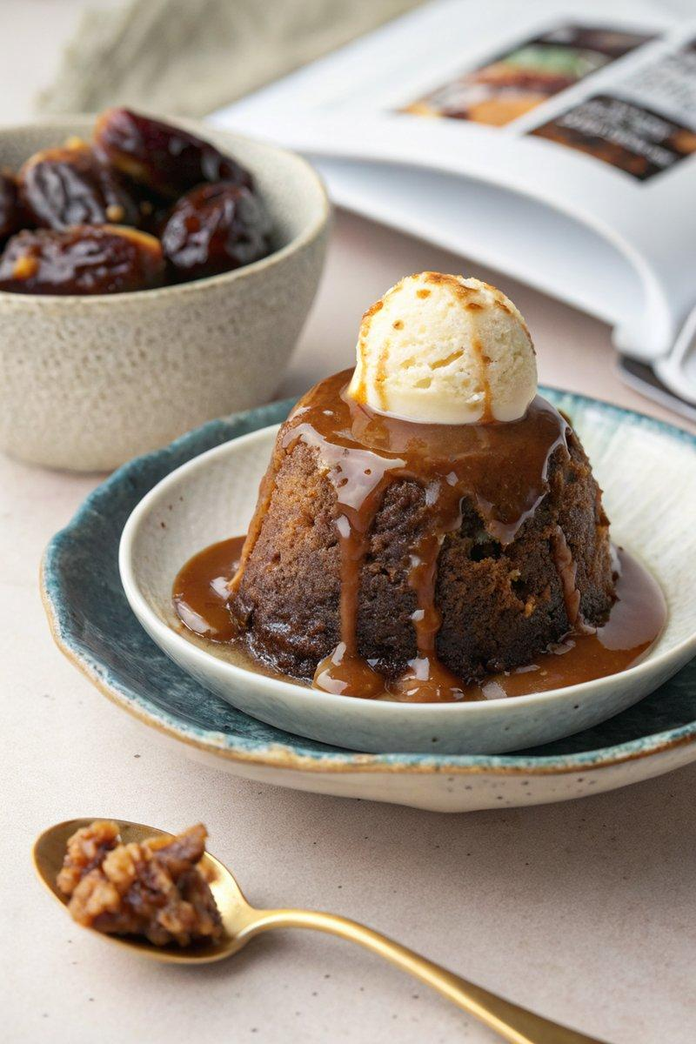

INGREDIENTS  - {'group': 'Sauce', 'item': '75g unsalted butter, cubed'}  - {'group': 'Sauce', 'item': '100g light brown soft sugar'}  - {'group': 'Sauce', 'item': '1 heaped tsp black treacle'}  - {'group': 'Sauce', 'item': '300ml double cream'}  - {'group': 'Main', 'item': '200g pitted dates, roughly chopped'}  - {'group': 'Main', 'item': '200ml boiling water'}  - {'group': 'Main', 'item': '1 tsp bicarbonate of soda'}  - {'group': 'Main', 'item': '75g unsalted butter, cubed'}  - {'group': 'Main', 'item': '50g light brown soft sugar'}  - {'group': 'Main', 'item': '2 tbsp black treacle'}  - {'group': 'Main', 'item': '2 eggs'}  - {'group': 'Main', 'item': '150g plain flour, sifted'}  - {'group': 'Main', 'item': '2 tsp baking powder'}  - {'group': 'Main', 'item': 'Pinch of salt'} | PREP  Grease a 1-litre pudding basin with butter and line the base with baking parchment. Combine dates, boiling water, and bicarbonate of soda in a bowl and let stand for 10 mins. In a stand mixer, cream butter, sugar, and treacle until fluffy. Beat in eggs one at a time, then fold in flour, baking powder, and salt. Mash dates and fold into batter.  COOK  Pour batter into prepared basin, leaving a 5cm gap at the top. Cover with baking parchment and foil, pleating to allow expansion, and secure with string. Place basin in a slow cooker, add boiling water halfway up the basin, cover with a tea towel and lid, and cook on high for 2 hrs. Meanwhile, make the sauce by melting butter, sugar, and treacle in a saucepan, then stir in cream and simmer briefly.  PLATING  Let pudding stand for 10 mins, then remove from slow cooker. Loosen edges with a knife, invert onto a plate, and serve with warmed toffee sauce. Optionally, accompany with double cream, vanilla ice cream, or custard.

NOTES:
No additional notes

