CLASSIC APPLE CRUMBLE  COOK TIME: 3 hours  SOURCE: Unknown  #apple #British #slow-cook | 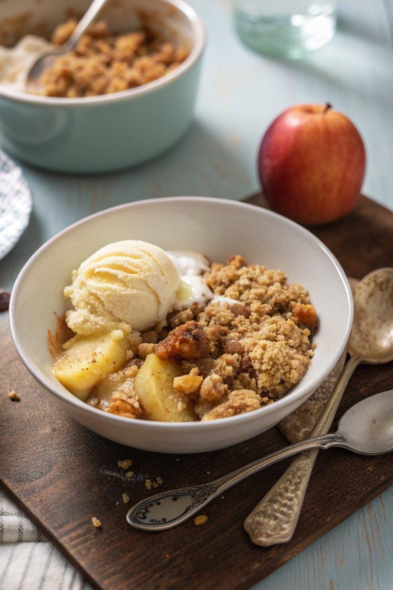

INGREDIENTS  - {'group': 'Filling', 'item': '6 cooking apples, peeled, cored, and cut into 2cm dice'}  - {'group': 'Filling', 'item': '15ml lemon juice'}  - {'group': 'Filling', 'item': '60g light brown soft sugar'}  - {'group': 'Filling', 'item': '1 tsp ground cinnamon'}  - {'group': 'Crumble', 'item': '150g unsalted butter, cubed'}  - {'group': 'Crumble', 'item': '225g plain flour, sifted'}  - {'group': 'Crumble', 'item': '75g jumbo oats'}  - {'group': 'Crumble', 'item': '75g light brown soft sugar'}  - {'group': 'Crumble', 'item': 'Pinch of sea salt flakes'} | PREP  Peel, core, and dice the apples into 2cm pieces. Juice the lemon. In a slow cooker, combine the apples, lemon juice, sugar, and cinnamon, tossing to coat evenly. Set aside.  COOK  In a mixing bowl, rub the butter into the flour using your fingers until it resembles breadcrumbs. Stir in the oats, sugar, and salt. Add 2 tbsp of water and gently shake the bowl to form larger crumble pieces. Spread the crumble over the apple mixture in the slow cooker. Cover with a clean tea towel under the lid to absorb steam. Cook on low for 3 hours until the apples are tender and the crumble is golden. For a crispier topping, transfer the slow cooker bowl to a preheated oven at 200°C (180°C (350°F (175°C)) fan) for 10-15 mins.  PLATING  Serve the apple crumble warm, optionally with custard, ice cream, or double cream.

NOTES:
For added flavour, consider mixing ground ginger or flaked almonds into the crumble. Ensure your slow cooker bowl is ovenproof if transferring to the oven.

