CHOCOLATE LAVA CAKE  COOK TIME: 2 hrs  SOURCE: Unknown  #chocolate #dessert #slow-cook | 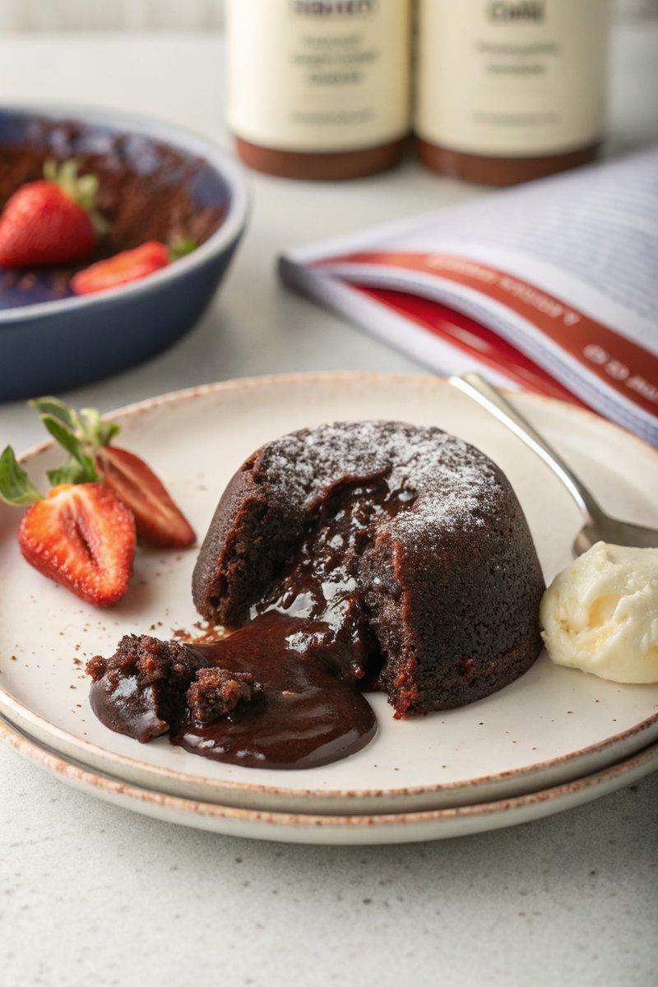

INGREDIENTS  - {'group': 'Main', 'item': '200g unsalted butter, plus extra for greasing'}  - {'group': 'Main', 'item': '200g 70% dark chocolate, roughly chopped'}  - {'group': 'Main', 'item': '100g light brown soft sugar'}  - {'group': 'Main', 'item': '3 eggs'}  - {'group': 'Main', 'item': '30g flour, sifted'}  - {'group': 'Main', 'item': 'big pinch of sea-salt flakes'}  - {'group': 'Main', 'item': 'cocoa powder, sifted for dusting'} | PREP  Set the slow cooker to high. Melt 200g of butter and half the chocolate in a heatproof bowl over simmering water. Allow to cool. In a stand mixer, whisk sugar and eggs until pale and fluffy. Fold in flour and sea-salt flakes.  COOK  Grease a 1-litre pudding basin with butter and dust with cocoa powder. Pour half of the batter into the basin, place the remaining chocolate in the center, and cover with the rest of the batter. Cover the basin with baking parchment and foil, making a pleat for expansion. Secure with kitchen string. Place the basin in the slow cooker, add boiling water halfway up the sides, cover, and cook on high for 2 hours until the edges are set but the center remains wobbly.  PLATING  Carefully remove the basin from the slow cooker. Remove the foil and parchment, loosen the edges with a knife, and invert onto a plate. Serve immediately.

NOTES:
Ensure the pudding basin is well-greased to prevent sticking. For a citrus twist, add orange zest to the batter. Serve with double cream, vanilla ice cream, or crème fraîche.

