MORTADELLA AND MOZZARELLA FRITTATA  COOK TIME: 10 mins  SOURCE: Unknown  #egg #Italian #bake | 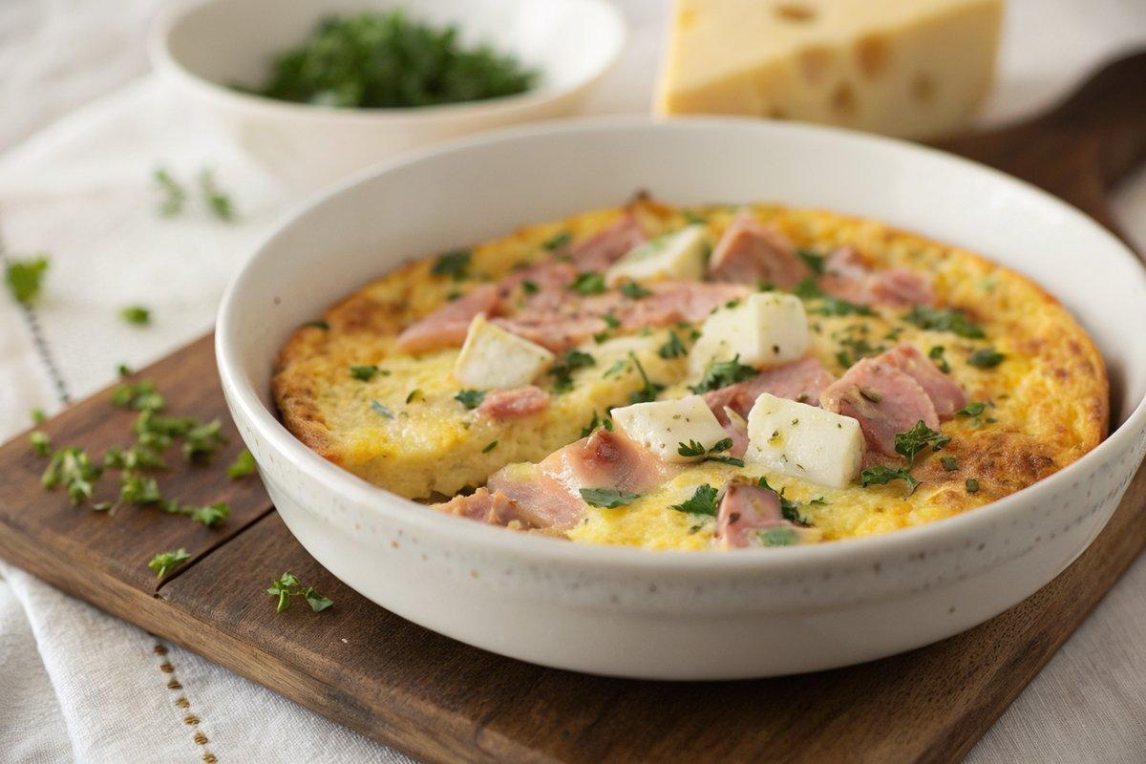

INGREDIENTS  - {'group': 'Main', 'item': '6 eggs'}  - {'group': 'Main', 'item': '125g mortadella, chopped'}  - {'group': 'Main', 'item': '125g fresh mozzarella cheese, chopped'}  - {'group': 'Seasoning', 'item': '1 tbsp chopped parsley, plus extra for sprinkling'}  - {'group': 'Seasoning', 'item': '1 tbsp freshly grated Parmesan cheese'}  - {'group': 'Seasoning', 'item': 'sea salt flakes and pepper, to taste'}  - {'group': 'Cooking', 'item': '15g butter'}  - {'group': 'Cooking', 'item': 'a drop of garlic oil'} | PREP  Preheat the grill. In a large bowl, beat the eggs thoroughly. Add the chopped mortadella and mozzarella, then whisk in the parsley, Parmesan, salt, and pepper.  COOK  Heat the butter and garlic oil in a 25cm ovenproof frying pan over medium heat. Once the butter is foamy, pour in the egg mixture. Cook gently for about 5 minutes until the bottom is set and golden. Transfer the pan to the grill and cook until the top is set, watching closely to avoid burning.  PLATING  Let the frittata rest for a couple of minutes. Run a knife around the edge to loosen, then slide it onto a serving plate. Cut into 8 wedges, sprinkle with extra parsley, and serve with green beans or a fresh salad.

NOTES:
Leftovers should be cooled and refrigerated promptly, and consumed within 1-2 days. Consider using leftover frittata in a sandwich for a quick meal.

