CHEESE AND CHORIZO CRUSTLESS PIE  COOK TIME: 33 mins  SOURCE: Unknown  #cheese #European #bake | 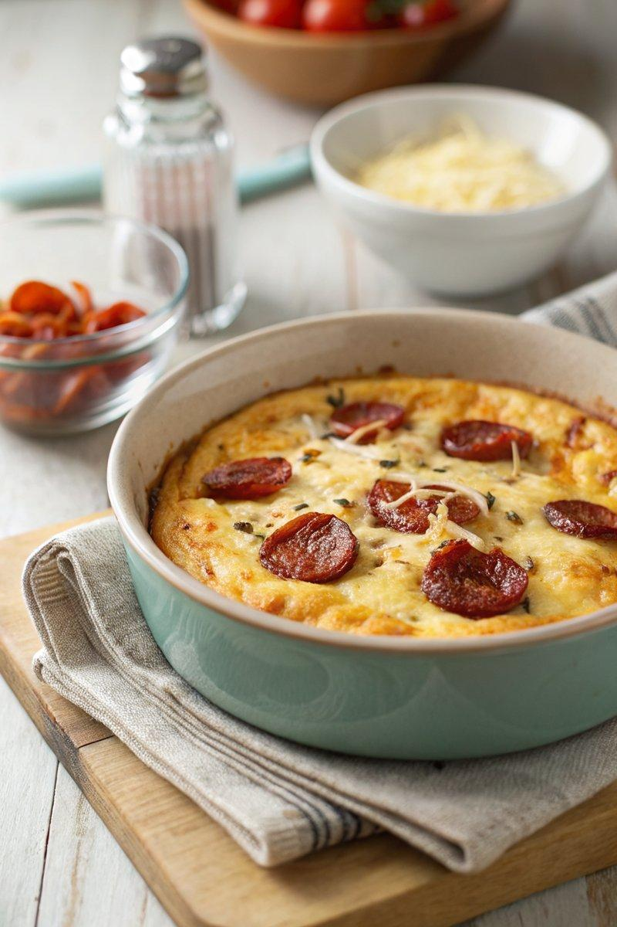

INGREDIENTS  - {'group': 'Main', 'item': '1 egg'}  - {'group': 'Main', 'item': '100g plain flour'}  - {'group': 'Main', 'item': 'Sea salt flakes, to taste'}  - {'group': 'Main', 'item': '250ml full-fat milk'}  - {'group': 'Main', 'item': 'Butter, for greasing'}  - {'group': 'Main', 'item': '100g grated Cheddar cheese'}  - {'group': 'Topping', 'item': '50g small chorizo slices, ~2cm diameter (optional)'} | PREP  Preheat the oven to 200°C (400°F (200°C)). In a bowl, beat the egg with flour, salt, and milk until smooth. Grease a 20cm (8-inch) round ovenproof dish.  COOK  Stir half of the grated Cheddar into the batter and pour it into the prepared dish. Bake for 30 minutes. Remove from the oven, sprinkle with remaining cheese and chorizo slices, then return to the oven for an additional 2-3 minutes until the cheese is melted and golden.  PLATING  Cut the crustless pie into slices and serve immediately. Pair with a green or tomato salad for a complete meal.

NOTES:
Ensure the dish is well-greased if using Pyrex or earthenware to prevent sticking.

