CRISPY CHICKEN CUTLETS WITH PARMESAN  COOK TIME: 15 mins  SOURCE: Unknown  #chicken #Italian #pan-fry | 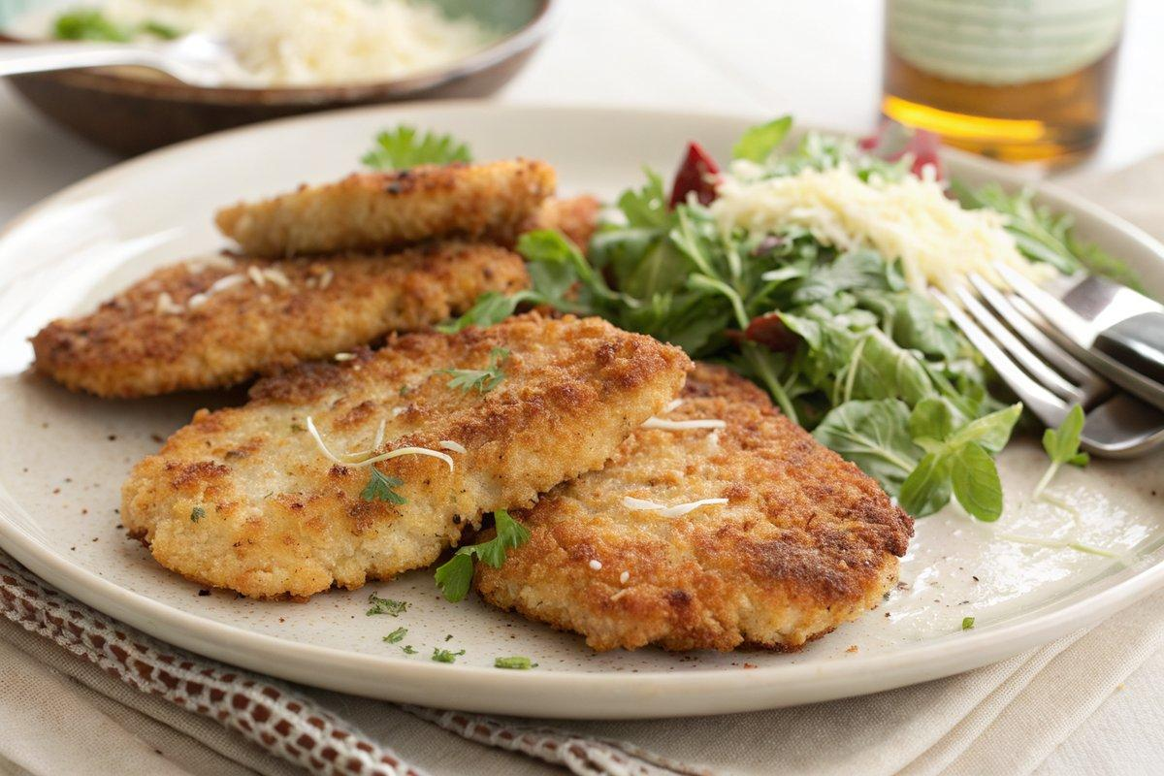

INGREDIENTS  - {'group': 'Main', 'item': '4 chicken breast fillets, skinless and boneless'}  - {'group': 'Marinade', 'item': '284ml buttermilk'}  - {'group': 'Marinade', 'item': '1 tbsp Worcestershire sauce'}  - {'group': 'Coating', 'item': '125g fresh breadcrumbs'}  - {'group': 'Coating', 'item': '1 tsp celery salt'}  - {'group': 'Coating', 'item': '1/2 tsp cayenne pepper'}  - {'group': 'Coating', 'item': '1 tsp dried thyme'}  - {'group': 'Coating', 'item': '50g Parmesan cheese, grated'}  - {'group': 'Garnish', 'item': '4 tbsp chopped fresh parsley'}  - {'group': 'For Frying', 'item': 'Oil for frying, such as groundnut oil'} | PREP  Place chicken breasts between two sheets of cling film and flatten with a rolling pin until thin. In a shallow bowl, whisk together buttermilk and Worcestershire sauce. Add chicken to the marinade and let sit for 30 minutes at room temperature or refrigerate overnight.  COOK  Preheat oven to 150°C (300°F (150°C)) if keeping cutlets warm. In a shallow dish, combine breadcrumbs, celery salt, cayenne pepper, thyme, and Parmesan. Remove chicken from marinade, allowing excess to drip off, and press into breadcrumb mixture to coat both sides. Heat oil in a frying pan over medium heat. Fry chicken pieces for about 3 minutes per side until golden brown and cooked through. Transfer to a paper towel-lined plate to drain excess oil.  PLATING  Serve the crispy chicken cutlets sprinkled with chopped parsley. Accompany with a side salad of baby spinach or rocket, diced tomatoes, and shaved Parmesan. Optionally, add lemon wedges for squeezing over the chicken.

NOTES:
For a lighter option, use a mixture of yogurt and milk instead of buttermilk. Leftovers can be refrigerated and reheated in a low oven.

