SWEET AND SOUR CHICKEN STIR-FRY  COOK TIME: 25 mins  SOURCE: Unknown  #chicken #asian #stir-fry | 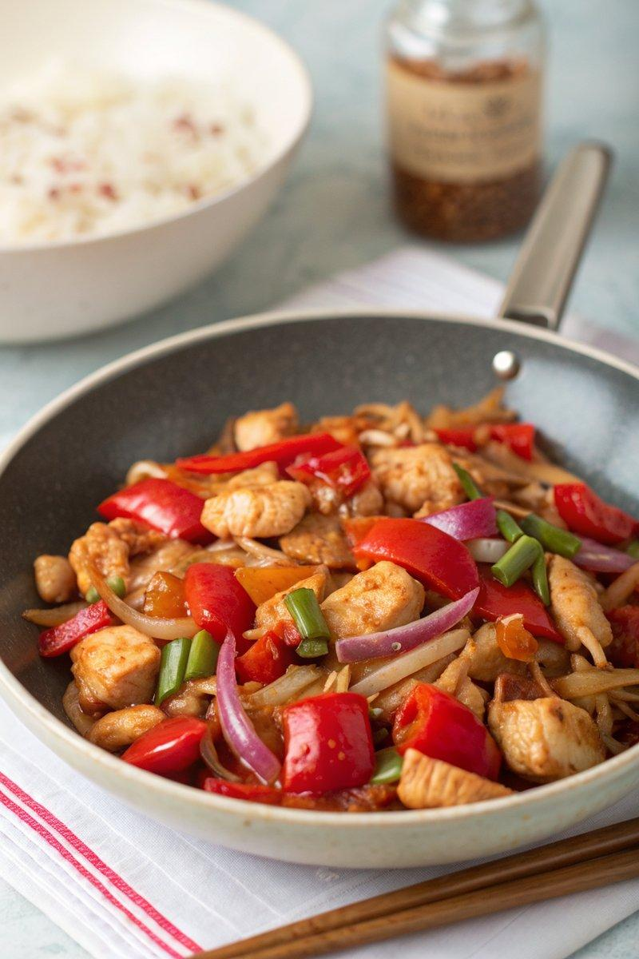

INGREDIENTS  - {'group': 'Main', 'item': '500g chicken thigh fillets, diced'}  - {'group': 'Main', 'item': '2 tbsp garlic oil'}  - {'group': 'Main', 'item': '1 red onion, peeled and chopped'}  - {'group': 'Main', 'item': '2 red peppers, cut into 4cm chunks'}  - {'group': 'Main', 'item': '1 tsp Chinese 5 spice powder'}  - {'group': 'Main', 'item': '300g beansprouts'}  - {'group': 'Main', 'item': '150g sliced water chestnuts'}  - {'group': 'Sauce', 'item': '2 tbsp apricot jam'}  - {'group': 'Sauce', 'item': '2 tbsp soy sauce'}  - {'group': 'Sauce', 'item': '25 ml pineapple juice'}  - {'group': 'Sauce', 'item': '3 tbsp tomato ketchup'}  - {'group': 'Sauce', 'item': '2 tsp rice wine vinegar'}  - {'group': 'Seasoning', 'item': 'Salt and pepper, to taste'} | PREP  Dice the chicken thighs into bite-sized pieces. Peel and chop the red onion. Remove the stalks and seeds from the red peppers, then cut them into 4cm chunks.  COOK  Heat the garlic oil in a large frying pan over medium heat. Add the chopped onion and sauté for about 5 mins until softened. Stir in the red peppers and cook for another 5 mins. Add the diced chicken and Chinese 5 spice powder, stirring frequently, and cook for 5 mins until the chicken is browned. In a bowl, whisk together the apricot jam, soy sauce, pineapple juice, tomato ketchup, and rice wine vinegar. Pour the sauce into the pan, bring to a boil, then reduce the heat to low. Cover and simmer for 15 mins until the chicken is cooked through. Stir in the beansprouts and water chestnuts, adjust seasoning with salt and pepper, and heat through.  PLATING  Serve the sweet and sour chicken hot over steamed rice.

NOTES:
This dish can be prepared a day in advance and reheated, but it's best served fresh for optimal texture and flavour.

