TURKEY MEATBALLS IN TOMATO SAUCE  COOK TIME: 30 mins  SOURCE: Unknown  #turkey #Italian #simmer | 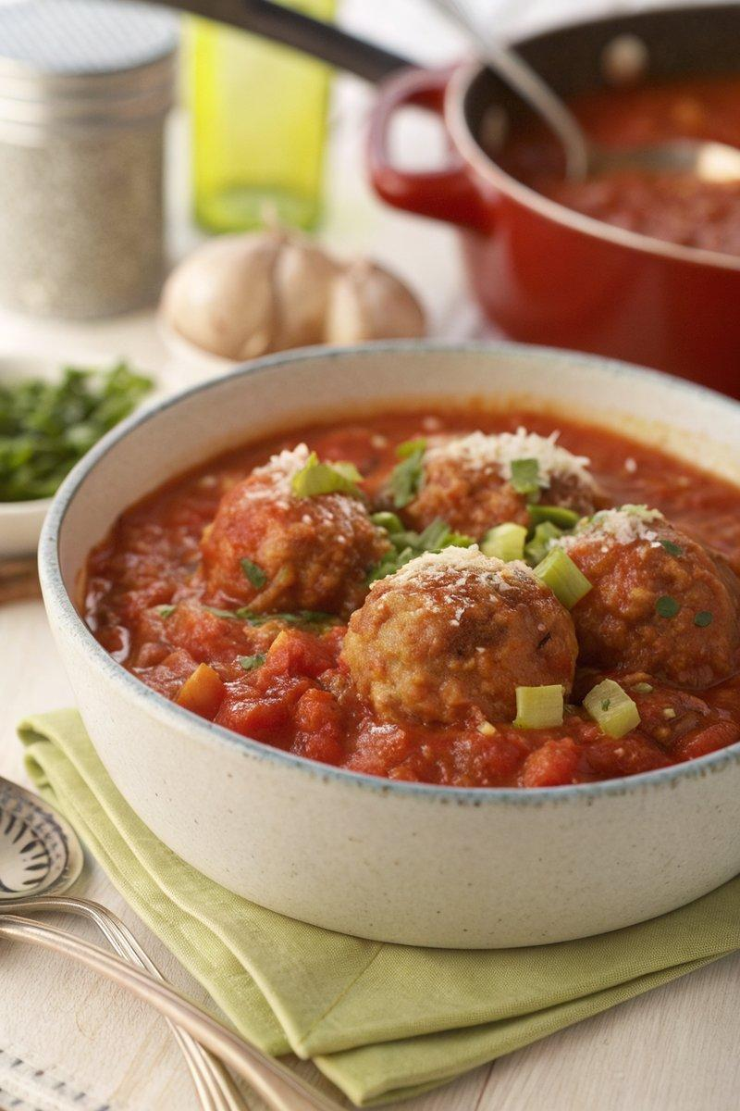

INGREDIENTS  - {'group': 'Main', 'item': '500g turkey mince'}  - {'group': 'Main', 'item': '1 onion, chopped'}  - {'group': 'Main', 'item': '2 stalks celery, chopped'}  - {'group': 'Sauce', 'item': '400g canned plum tomatoes, chopped'}  - {'group': 'Sauce', 'item': '50g Parmesan cheese, grated'} | PREP  Chop the onion and celery finely. Grate the Parmesan cheese. Open and chop the canned plum tomatoes.  COOK  In a large pot, combine the turkey mince, chopped onion, and celery. Cook over medium heat until the turkey is browned and the vegetables are softened, about 10 mins. Add the chopped plum tomatoes and grated Parmesan cheese to the pot. Stir well and bring to a simmer. Cover and cook for an additional 20 mins, stirring occasionally, until the sauce thickens and the flavours meld.  PLATING  Serve the turkey meatballs hot, garnished with additional Parmesan cheese if desired. Pair with spaghetti or garlic bread for a complete meal.

NOTES:
Ensure the turkey is cooked through before serving. Adjust seasoning with salt and pepper to taste.

