BAKED CHICKEN DRUMSTICKS WITH APRICOT GLAZE  COOK TIME: 45 mins to 1 hr  SOURCE: Unknown  #chicken #African #bake | 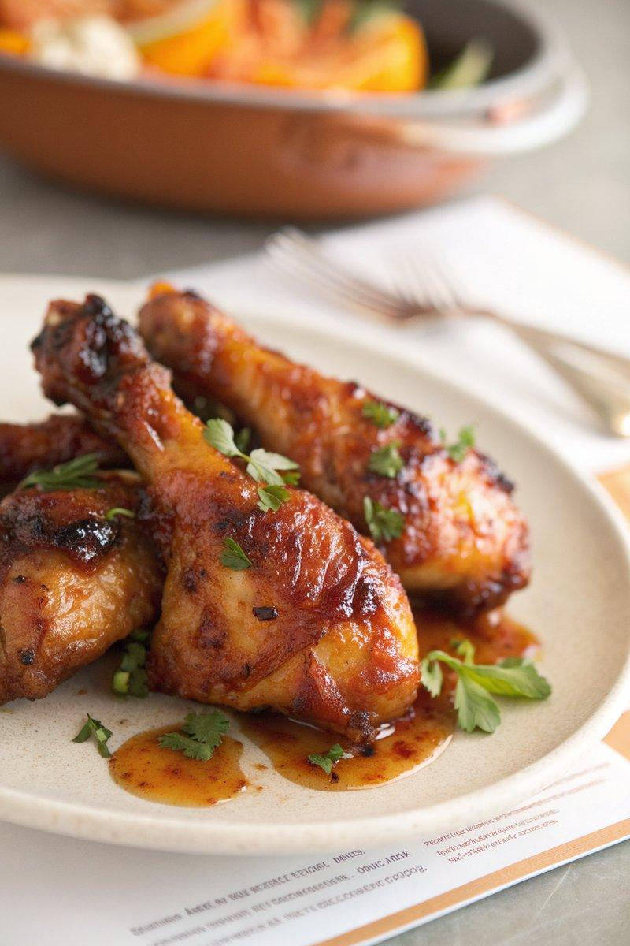

INGREDIENTS  - {'group': 'Main', 'item': '8 chicken drumsticks, preferably organic'}  - {'group': 'Sauce', 'item': '80ml Worcestershire sauce'}  - {'group': 'Sauce', 'item': '60ml tomato ketchup'}  - {'group': 'Sauce', 'item': '2 tsp English mustard powder'}  - {'group': 'Sauce', 'item': '1 tsp ground ginger'}  - {'group': 'Sauce', 'item': '1 tbsp apricot jam'}  - {'group': 'Sauce', 'item': '1 onion, peeled and finely chopped'}  - {'group': 'Main', 'item': '1 tbsp garlic oil'} | PREP  Preheat the oven to 200°C (400°F (200°C)). In a shallow dish, combine Worcestershire sauce, tomato ketchup, mustard powder, ground ginger, apricot jam, and chopped onion to create the marinade. Coat the chicken drumsticks thoroughly in the marinade. If desired, marinate in the fridge overnight for enhanced flavour.  COOK  Drizzle garlic oil into a small roasting tin, ensuring the base is covered. Arrange the marinated drumsticks snugly in the tin and pour any remaining marinade over them. Bake in the preheated oven for 45 minutes to 1 hour, basting occasionally, until the drumsticks are golden and cooked through.  PLATING  Serve the drumsticks hot, optionally accompanied by a side of steamed rice and a green salad.

NOTES:
The chicken can be marinated overnight for deeper flavour. It can also be frozen in the marinade for up to 3 months; defrost before cooking.

