MUSSELS IN CIDER  COOK TIME: 10 mins  SOURCE: Unknown  #mussels #French #simmer | 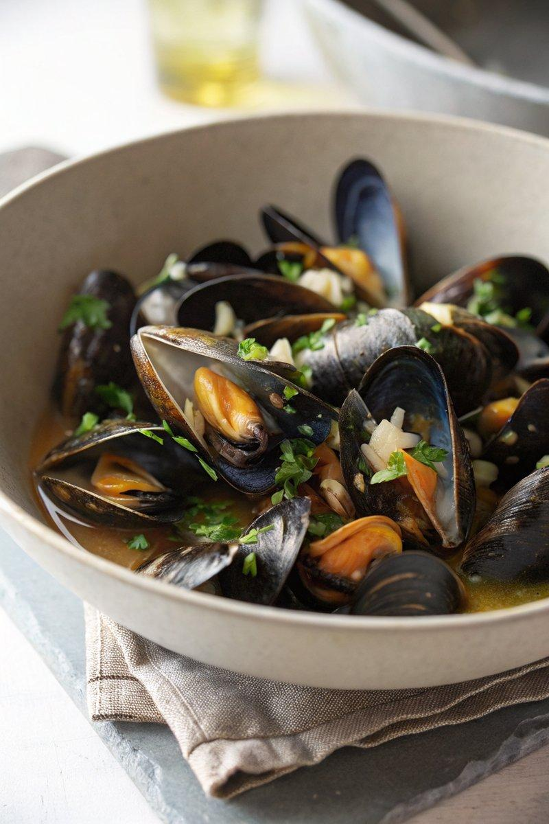

INGREDIENTS  - {'group': 'Main', 'item': '2kg mussels'}  - {'group': 'Main', 'item': '2-3 tbsp olive oil'}  - {'group': 'Main', 'item': '1 onion, finely chopped or 3 spring onions, sliced'}  - {'group': 'Main', 'item': '2 cloves garlic, finely sliced'}  - {'group': 'Main', 'item': '500ml dry cider'}  - {'group': 'Garnish', 'item': '3-4 tbsp chopped fresh parsley'} | PREP  Soak the mussels in cold water, cleaning them by scraping off barnacles and removing beards. Discard any cracked or open mussels that do not close when tapped.  COOK  Heat olive oil in a large pan over medium heat. Add the onion and garlic, cooking until softened. Stir in 1 tbsp of parsley. Pour in the cider, increase the heat, and add the cleaned mussels. Cover with a lid and cook for 2-3 mins, shaking the pan occasionally, until the mussels open.  PLATING  Divide the mussels among bowls, spooning the cooking liquid over them while avoiding any sediment. Sprinkle with remaining parsley and serve with crusty bread for dipping.

NOTES:
No additional notes

