LAMB STEAKS WITH ROSEMARY AND PORT SAUCE  COOK TIME: 10 mins  SOURCE: Unknown  #lamb #Mediterranean #pan-fry | 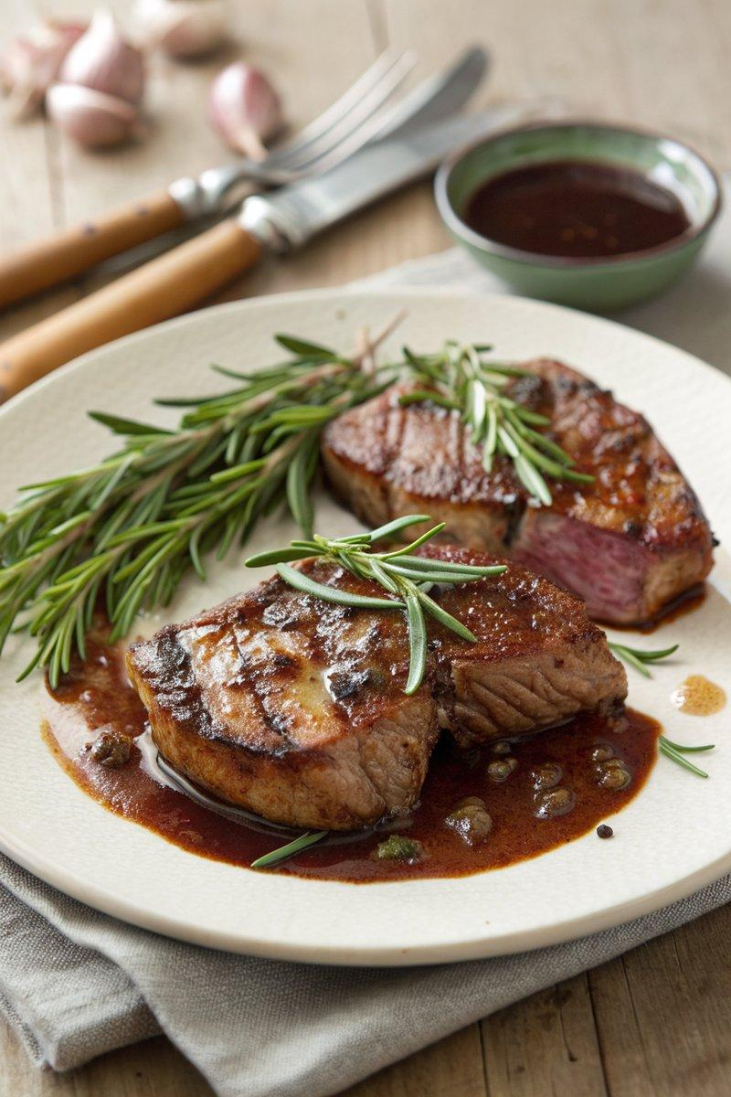

INGREDIENTS  - {'group': 'Main', 'item': '2 boneless lamb leg steaks'}  - {'group': 'Marinade', 'item': '15ml olive oil'}  - {'group': 'Marinade', 'item': '2 tsp Worcestershire sauce'}  - {'group': 'Sauce', 'item': '15g butter'}  - {'group': 'Sauce', 'item': '1 sprig rosemary'}  - {'group': 'Sauce', 'item': '1 clove garlic'}  - {'group': 'Sauce', 'item': '60ml ruby port'} | PREP  Mix the olive oil and Worcestershire sauce in a bowl. Coat the lamb steaks with this mixture using a pastry brush or by dipping them directly into the bowl. Finely chop the rosemary needles and crush or finely chop the garlic clove.  COOK  Heat a heavy-based frying pan over medium-high heat. Cook the lamb steaks for about 3 minutes on each side, adjusting for thickness and desired doneness. Remove the steaks, wrap in foil, and let them rest on a warm plate. Reduce the heat to low, add butter to the pan, and let it melt. Add the chopped rosemary and garlic, then pour in the port. Allow the sauce to sizzle and reduce slightly. Unwrap the steaks and add any juices from the foil to the sauce.  PLATING  Place the lamb steaks on plates and pour the rosemary and port sauce over them. Serve immediately with steamed baby potatoes or green beans.

NOTES:
For a variation, try serving with orzo or warmed cannellini beans.

