TARRAGON CHICKEN WITH VERMOUTH CREAM SAUCE  COOK TIME: 20 mins  SOURCE: Unknown  #chicken #French #pan-fry | 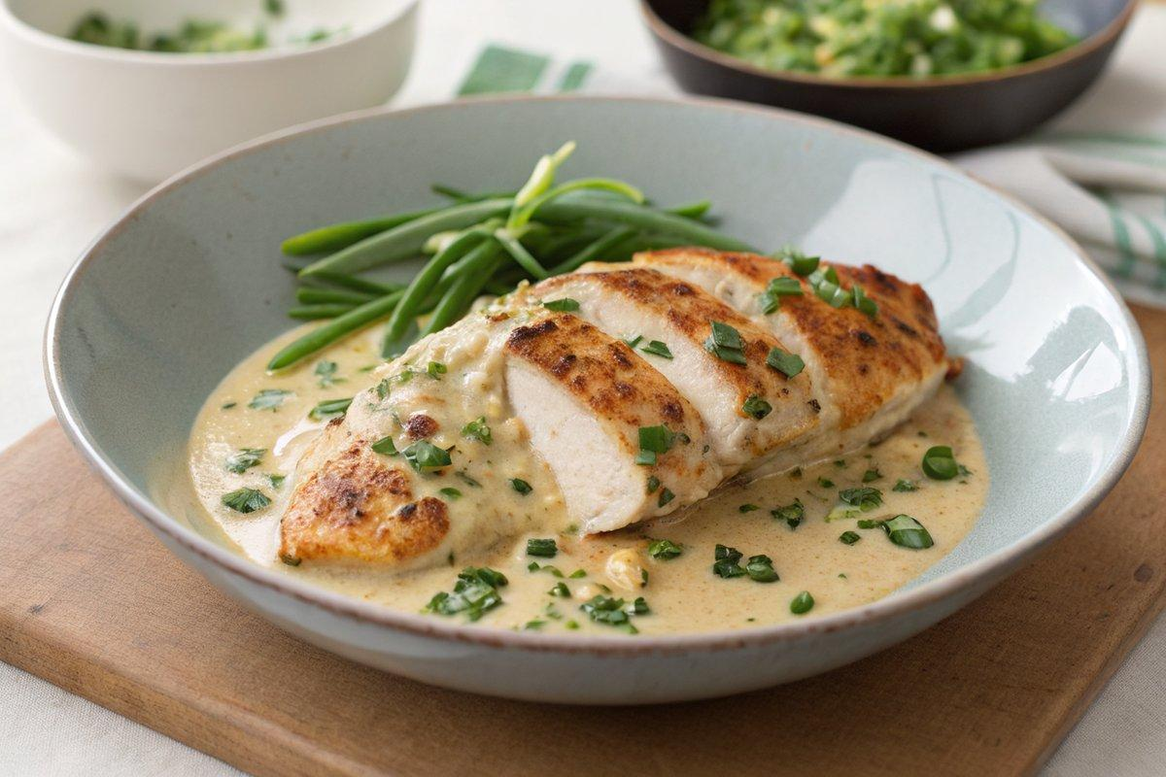

INGREDIENTS  - {'group': 'Main', 'item': '2 chicken breast fillets, skinless and boneless'}  - {'group': 'Main', 'item': '2 tsp garlic oil'}  - {'group': 'Main', 'item': '2 spring onions, finely sliced'}  - {'group': 'Seasoning', 'item': '1 tsp freeze-dried tarragon'}  - {'group': 'Sauce', 'item': '60ml vermouth or white wine'}  - {'group': 'Sauce', 'item': '150ml double cream'}  - {'group': 'Seasoning', 'item': '1/2 tsp sea salt flakes'}  - {'group': 'Seasoning', 'item': 'Fresh white pepper, to taste'}  - {'group': 'Garnish', 'item': '2 tsp chopped fresh tarragon'} | PREP  Slice the spring onions finely and chop the fresh tarragon. Measure out the vermouth and double cream.  COOK  Heat the garlic oil in a frying pan over medium heat. Add the spring onions and freeze-dried tarragon, sautéing until fragrant. Place the chicken breasts in the pan, searing each side for about 5 minutes until lightly browned. Pour in the vermouth and cover the pan, reducing the heat to low. Simmer for 10 minutes, ensuring the chicken is cooked through. Remove the chicken and set aside. Increase the heat and stir in the double cream, allowing the sauce to thicken slightly.  PLATING  Place the chicken breasts on warmed plates. Pour the vermouth cream sauce over the chicken and sprinkle with fresh tarragon. Serve immediately.

NOTES:
For a richer flavour, consider adding a teaspoon of Dijon mustard to the sauce. Serve with steamed asparagus and new potatoes for a complete meal.

