REDCURRANT AND MINT LAMB CUTLETS  COOK TIME: 10 mins  SOURCE: Unknown  #lamb #British #pan-fry | 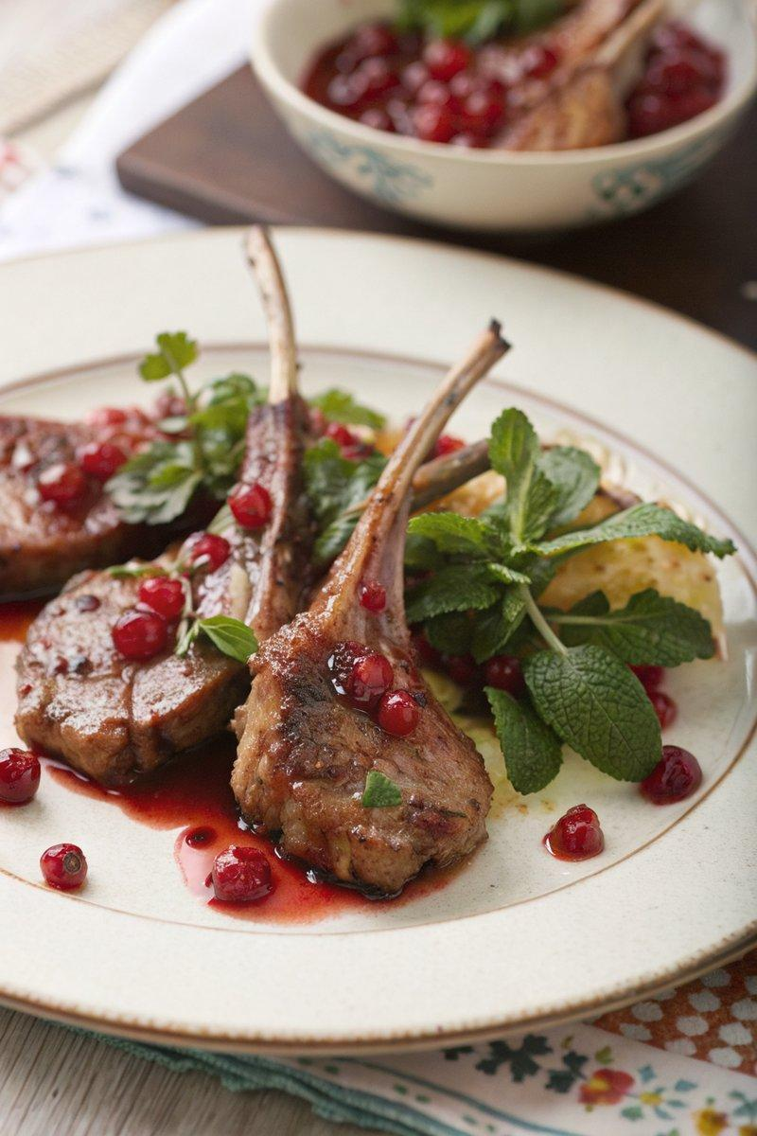

INGREDIENTS  - {'group': 'Main', 'item': '1 tbsp garlic oil'}  - {'group': 'Main', 'item': '6 lamb cutlets'}  - {'group': 'Sauce', 'item': '75ml juice from 1 clementine or satsuma'}  - {'group': 'Sauce', 'item': '1 tbsp redcurrant jelly'}  - {'group': 'Sauce', 'item': 'dash Worcestershire sauce'}  - {'group': 'Sauce', 'item': 'dash red wine vinegar or sherry vinegar'}  - {'group': 'Seasoning', 'item': 'salt and pepper, to taste'}  - {'group': 'Garnish', 'item': 'small bunch fresh mint, finely chopped'} | PREP  Finely chop the fresh mint and set aside. Juice the clementine or satsuma to obtain approximately 75ml of juice.  COOK  Heat the garlic oil in a frying pan over medium-high heat. Add the lamb cutlets and cook for 2-4 minutes on each side, depending on your preferred doneness and the thickness of the cutlets. Remove the cutlets and wrap them in foil to rest. Reduce the heat to low and whisk in the clementine juice, redcurrant jelly, Worcestershire sauce, vinegar, salt, and pepper. Stir until the sauce is smooth and heated through.  PLATING  Unwrap the lamb cutlets and place them on warmed plates. Pour any juices from the foil into the sauce, whisking to combine. Drizzle the sauce over the cutlets and sprinkle with chopped mint. Serve immediately, offering additional mint at the table.

NOTES:
No additional notes

