PAN-FRIED TURKEY SCALOPPINE WITH LEMON SAUCE AND CRISPY GNOCCHI  COOK TIME: 20 mins  SOURCE: Unknown  #turkey #Italian #pan-fry | 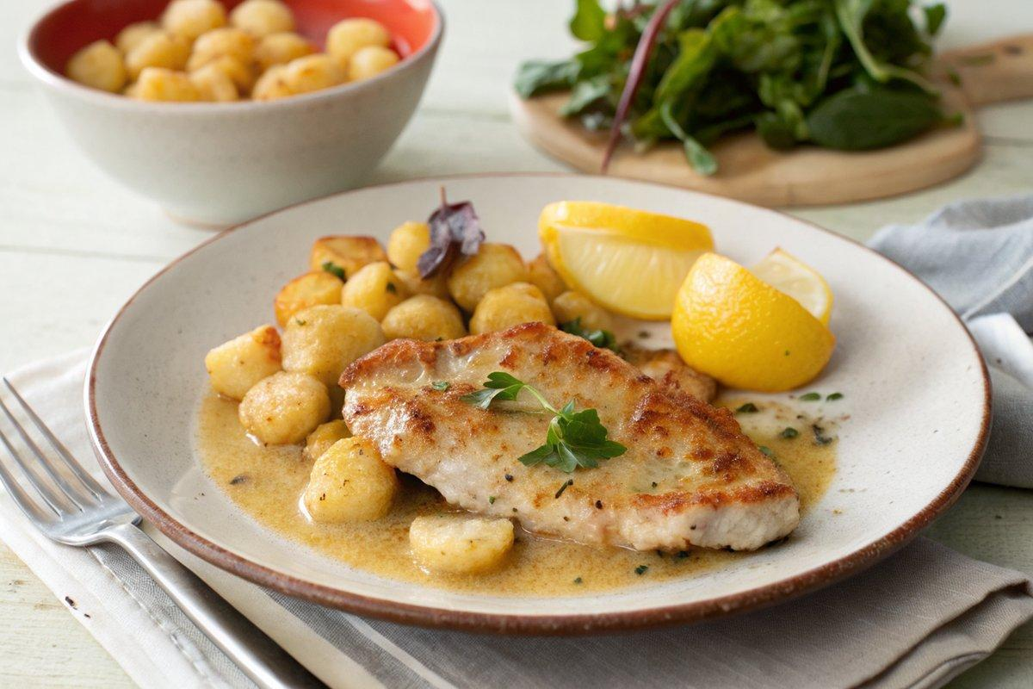

INGREDIENTS  - {'group': 'Main', 'item': '4 small turkey escalopes, about 350g total'}  - {'group': 'Coating', 'item': '30ml plain flour'}  - {'group': 'Coating', 'item': 'shake of mixed spice'}  - {'group': 'Coating', 'item': 'shake of cayenne pepper'}  - {'group': 'Sauce', 'item': 'zest and juice of 1 lemon'}  - {'group': 'Main', 'item': '30ml garlic oil'}  - {'group': 'Main', 'item': '250g gnocchi'}  - {'group': 'Main', 'item': '30ml regular olive oil'}  - {'group': 'Seasoning', 'item': 'salt, to taste'} | PREP  Place the flour, mixed spice, and cayenne pepper in a freezer bag. Add the turkey escalopes and shake to coat evenly. Zest and juice the lemon, keeping them separate.  COOK  Heat the garlic oil in a heavy-based frying pan over medium heat. Add the floured turkey escalopes and cook for 2 minutes on each side until just cooked through. Remove the turkey to warm plates. Off the heat, add the lemon zest and juice to the pan, stirring until the sauce is golden and slightly syrupy. In a separate pan, heat the olive oil and add the gnocchi, ensuring they are separated. Fry for 4 minutes, then turn and fry for another 4 minutes until golden and crispy.  PLATING  Pour the lemon sauce over the turkey escalopes. Serve immediately with the crispy gnocchi on the side.

NOTES:
For a baked version of the gnocchi, preheat the oven to 200°C (400°F (200°C)), toss the gnocchi with olive oil in a roasting pan, and bake for 20 minutes, stirring halfway through.

