PAN-FRIED SOLE WITH TARTARE SAUCE  COOK TIME: 5 mins  SOURCE: Unknown  #fish #European #pan-fry | 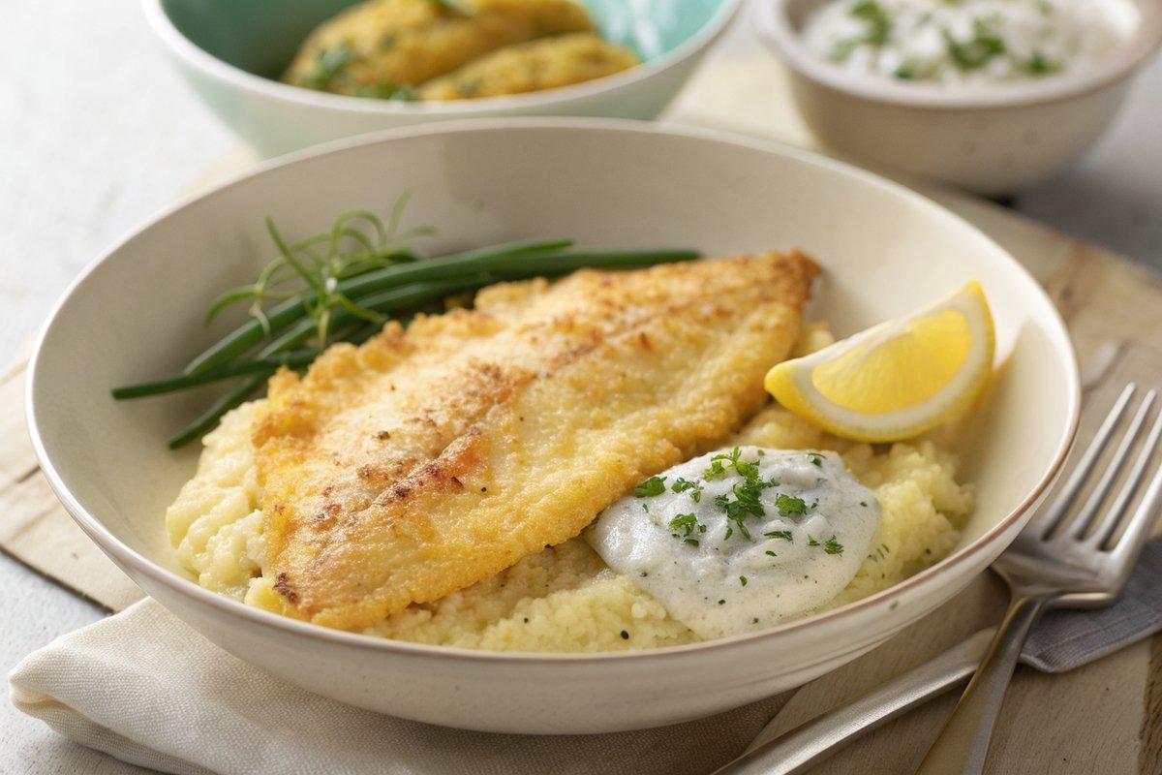

INGREDIENTS  - {'group': 'Main', 'item': '2 sole fillets'}  - {'group': 'Main', 'item': '1 egg'}  - {'group': 'Main', 'item': 'dash garlic oil'}  - {'group': 'Main', 'item': '125g instant polenta'}  - {'group': 'Main', 'item': 'groundnut or corn oil for frying'}  - {'group': 'Seasoning', 'item': 'salt and pepper'}  - {'group': 'Sauce', 'item': 'zest and juice of 1 lemon'}  - {'group': 'Sauce', 'item': '100g crème fraîche'}  - {'group': 'Sauce', 'item': '2 tsp baby capers, drained'}  - {'group': 'Sauce', 'item': '50g gherkins or cornichons, chopped'}  - {'group': 'Sauce', 'item': '3 rings jalapeño chilli peppers, chopped'}  - {'group': 'Sauce', 'item': '2 tbsp chopped fresh parsley'} | PREP  In a shallow dish, beat the egg with garlic oil, salt, and pepper. In another dish, place the polenta. Zest and juice the lemon, and chop the gherkins, jalapeños, tarragon, and parsley.  COOK  Dip each sole fillet in the egg mixture, then coat with polenta, pressing to adhere. Heat oil in a frying pan over medium heat. Fry the fillets for 1-2 mins per side until golden and cooked through.  PLATING  Serve the crispy sole fillets with a generous dollop of tartare sauce, garnished with extra tarragon and parsley. Accompany with a green salad and pickled vegetables.

NOTES:
Ensure the oil is hot before adding the fish to achieve a crispy coating. The tartare sauce can be made ahead and stored in the fridge.

