SCALLOPS WITH THAI GREEN CURRY PEA PURÉE  COOK TIME: 10 mins  SOURCE: Unknown  #scallops #asian #pan-fry | 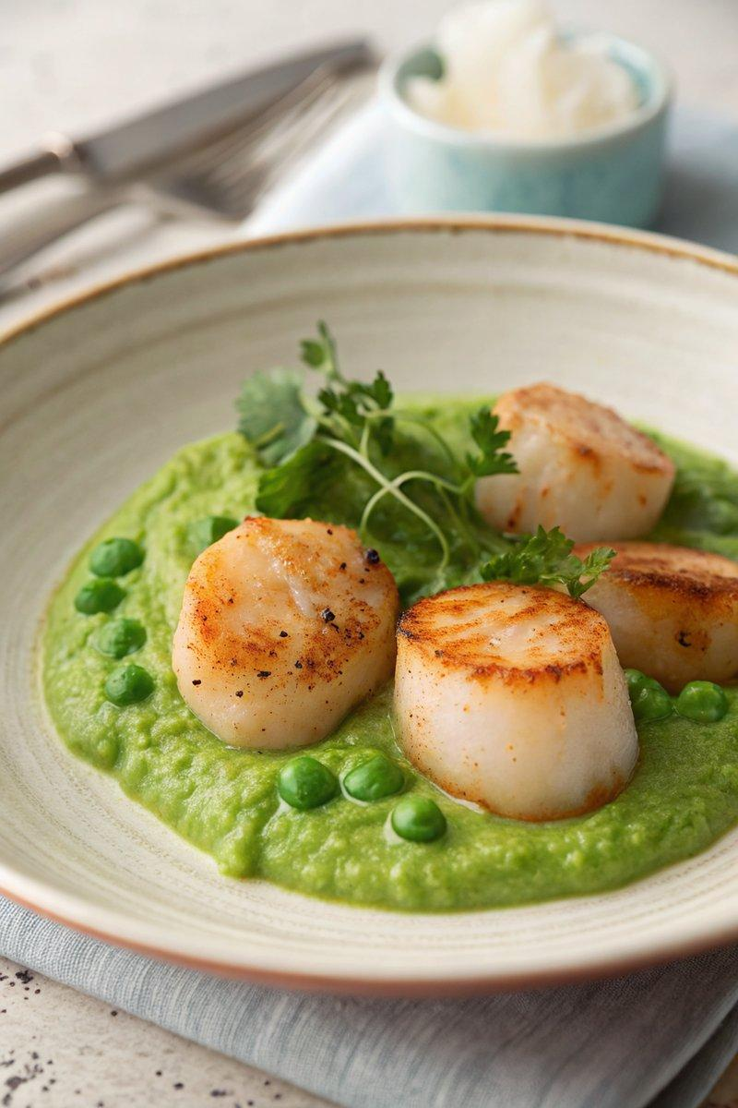

INGREDIENTS  - {'group': 'Main', 'item': '6 large scallops or 10-12 small scallops'}  - {'group': 'Main', 'item': '2 tsp groundnut oil'}  - {'group': 'Main', 'item': '2 tsp butter'}  - {'group': 'Purée', 'item': '500g frozen petits pois'}  - {'group': 'Purée', 'item': '1-2 tbsp Thai green curry paste'}  - {'group': 'Purée', 'item': '75g crème fraîche'}  - {'group': 'Seasoning', 'item': 'sea salt flakes, to taste'}  - {'group': 'Garnish', 'item': 'juice of 1 lime'}  - {'group': 'Garnish', 'item': '1-2 tbsp chopped fresh coriander or Thai basil'} | PREP  Cook the frozen peas in boiling salted water until tender, then drain. Transfer the peas to a blender, adding 1 tbsp of Thai green curry paste and the crème fraîche. Blend until smooth, seasoning with salt and additional curry paste if desired.  COOK  Heat the groundnut oil and butter in a frying pan over medium-high heat until foamy. Add the scallops and cook for about 2 minutes on each side, until they are golden-brown and just cooked through. Remove the scallops from the pan and set aside on warmed plates.  PLATING  De-glaze the pan with lime juice, stirring to incorporate the browned bits. Pour this over the scallops. Serve the scallops alongside the pea purée, garnished with chopped coriander or Thai basil. Add a wedge of lime on the side for extra zest.

NOTES:
The pea purée can be prepared a few hours in advance. After cooking, cool the peas quickly under cold water, then blend with curry paste and crème fraîche. Store in the fridge and reheat gently before serving.

