KOREAN STIR-FRIED CALAMARI  COOK TIME: 10 mins  SOURCE: Unknown  #seafood #asian #stir-fry | 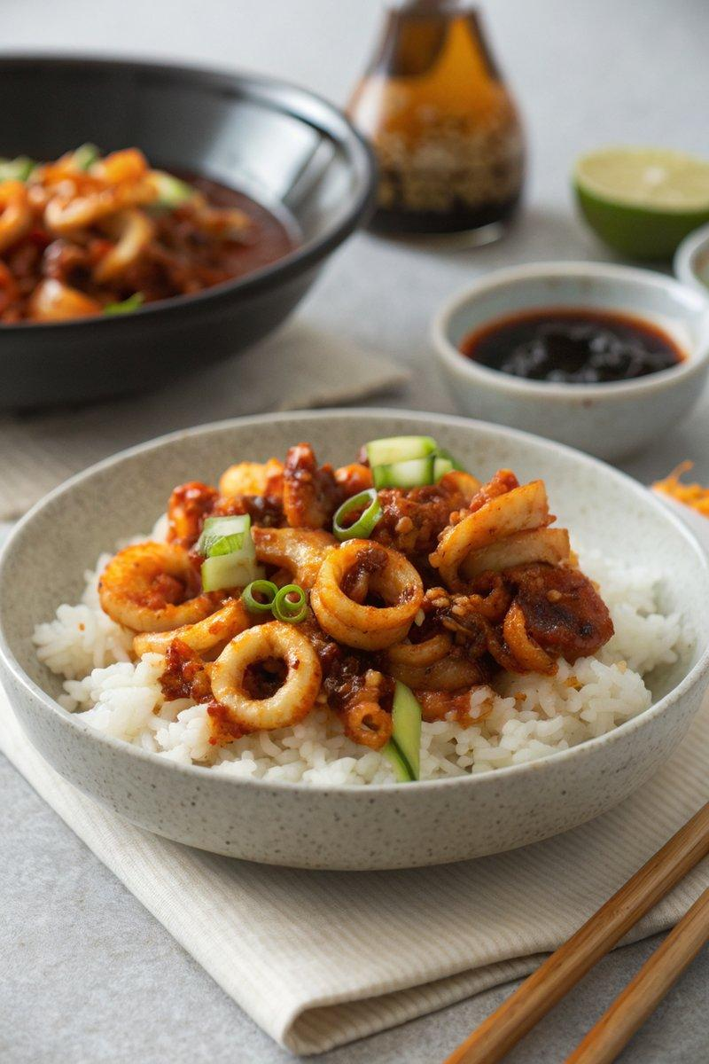

INGREDIENTS  - {'group': 'Main', 'item': '150g sushi rice'}  - {'group': 'Main', 'item': '150-175g squid, cleaned and sliced into rings'}  - {'group': 'Sauce', 'item': '2 tbsp rice wine'}  - {'group': 'Sauce', 'item': '2 tbsp Korean gochujang paste'}  - {'group': 'Sauce', 'item': '2 tbsp soy sauce'}  - {'group': 'Sauce', 'item': '2 tsp sugar'}  - {'group': 'Sauce', 'item': 'few dashes sesame oil'}  - {'group': 'Main', 'item': '2 tsp groundnut oil'}  - {'group': 'Main', 'item': '75g baby corn, cut into 2cm chunks'}  - {'group': 'Main', 'item': '6 thin spring onions, sliced'} | PREP  Cook the sushi rice according to the package instructions. Clean the squid, separating the tentacles and slicing the bodies into rings. Marinate the squid in rice wine for 15 minutes, then drain and reserve the liquid. Mix the reserved liquid with gochujang paste, soy sauce, sugar, and sesame oil to create the sauce.  COOK  Heat a wok over high heat and add groundnut oil. Stir-fry the baby corn and spring onions for 2 minutes. Add the marinated squid and stir-fry for another 1-2 minutes until the squid turns opaque. Pour in the prepared sauce and stir-fry for 30 seconds until heated through.  PLATING  Divide the cooked sushi rice between two bowls. Top with the stir-fried calamari and vegetables. Serve immediately.

NOTES:
Ensure the squid is not overcooked to maintain its tenderness. Adjust the level of spiciness by varying the amount of gochujang paste.

