KOREAN-STYLE TURKEY KEEMA  COOK TIME: 20 mins  SOURCE: Unknown  #turkey #asian #stir-fry | 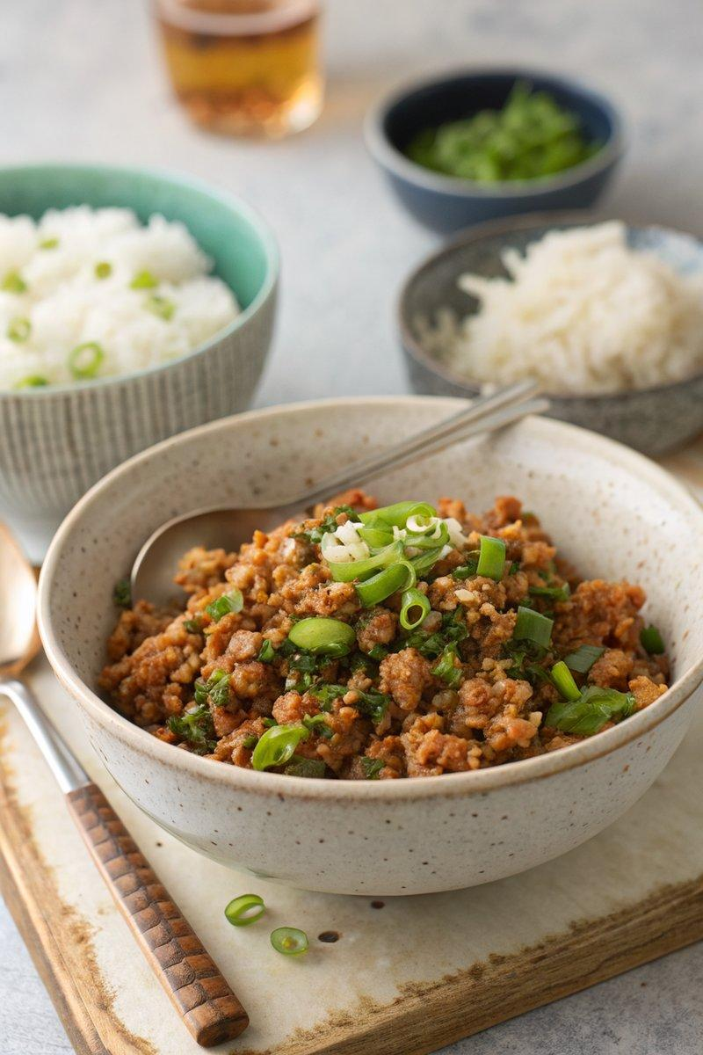

INGREDIENTS  - {'group': 'Main', 'item': '250g turkey mince'}  - {'group': 'Main', 'item': '125g frozen petits pois'}  - {'group': 'Main', 'item': '3 spring onions, chopped'}  - {'group': 'Sauce', 'item': '1 tbsp honey'}  - {'group': 'Sauce', 'item': '1 tbsp rice wine'}  - {'group': 'Garnish', 'item': '1-2 tbsp chopped fresh coriander'}  - {'group': 'For Serving', 'item': '240g sushi rice'} | PREP  Rinse the sushi rice under cold water until the water runs clear. Chop the spring onions and set aside. Measure out the soy sauce, honey, and rice wine for the sauce.  COOK  Cook the sushi rice according to package instructions or in a rice cooker. In a large frying pan or wok, heat a tablespoon of vegetable oil over medium-high heat. Add the turkey mince and cook until browned, breaking it up with a spoon. Stir in the chopped spring onions and cook for another 2 minutes. Add the soy sauce, honey, and rice wine, stirring to combine. Finally, add the frozen peas and cook until heated through.  PLATING  Serve the turkey keema over the cooked sushi rice, garnished with chopped fresh coriander.

NOTES:
For a spicier version, add a pinch of red pepper flakes or a dash of hot sauce to the turkey mixture.

