LINGUINE WITH WHITE TRUFFLE OIL  COOK TIME: 10 mins  SOURCE: Unknown  #pasta #Italian #quick | 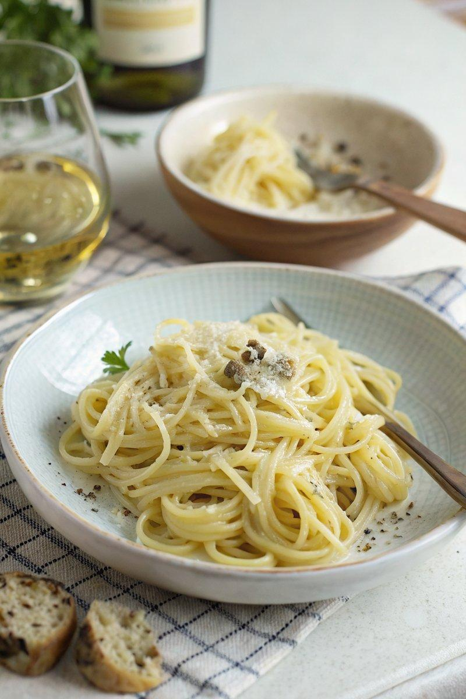

INGREDIENTS  - {'group': 'Main', 'item': '125g linguine pasta'}  - {'group': 'Sauce', 'item': '1 egg'}  - {'group': 'Sauce', 'item': '45ml double cream'}  - {'group': 'Sauce', 'item': '45ml grated Parmesan cheese'}  - {'group': 'Sauce', 'item': 'few drops white truffle oil'}  - {'group': 'Seasoning', 'item': 'freshly ground white pepper'}  - {'group': 'Main', 'item': '15g butter'} | PREP  Bring a pot of water to a boil and generously salt it. In a bowl, whisk together the egg, double cream, grated Parmesan, a few drops of white truffle oil, and a good grinding of white pepper.  COOK  Add the linguine to the boiling water and cook for 2 minutes less than the package instructions for al dente. Reserve a small cup of the pasta cooking water before draining. Return the drained pasta to the pot, off the heat, and add the butter along with about 15ml of the reserved cooking water. Stir until the butter melts and coats the pasta.  PLATING  Mix in the egg and cream mixture, stirring continuously until the pasta is evenly coated and creamy. Adjust seasoning with salt or more truffle oil if desired. Serve immediately in a warm bowl.

NOTES:
This dish is best enjoyed immediately to appreciate the delicate aroma of the truffle oil. Adjust the amount of truffle oil to your taste preference.

