VIETNAMESE PORK NOODLE SOUP  COOK TIME: 15 mins  SOURCE: Unknown  #pork #asian #soup | 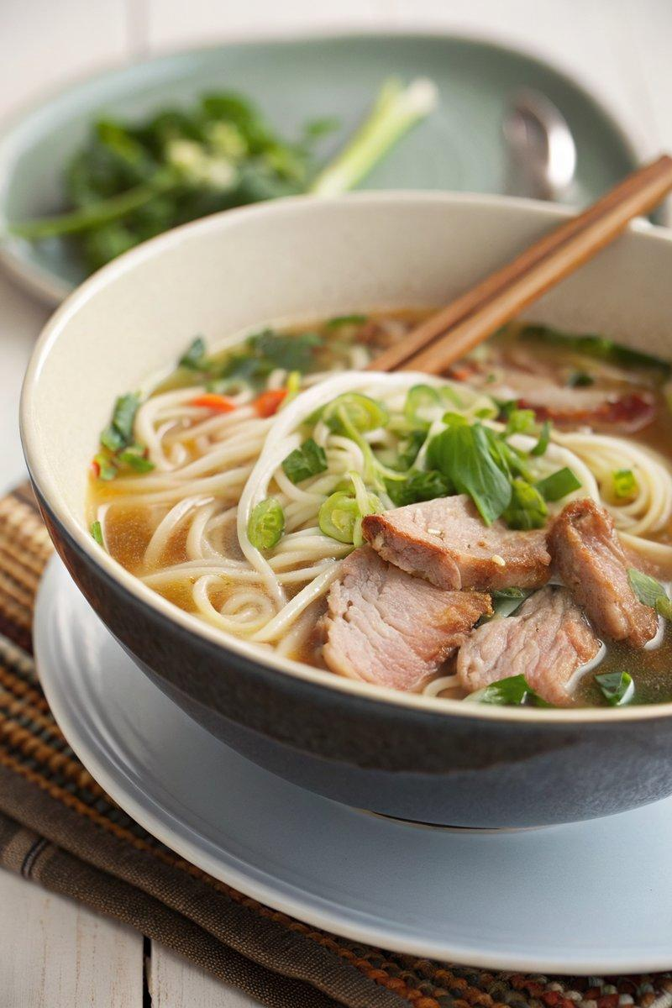

INGREDIENTS  - {'group': 'Main', 'item': '275g pork fillet, cut into thin strips'}  - {'group': 'Marinade', 'item': '2 tbsp lime juice'}  - {'group': 'Marinade', 'item': '2 tbsp soy sauce'}  - {'group': 'Marinade', 'item': '1/2 tsp paprika'}  - {'group': 'Marinade', 'item': '2 tbsp fish sauce'}  - {'group': 'Main', 'item': '250g ramen noodles'}  - {'group': 'Main', 'item': '1 tbsp garlic oil'}  - {'group': 'Main', 'item': '6 thin or 3 fat spring onions, finely sliced'}  - {'group': 'Main', 'item': '1 tbsp chopped fresh ginger'}  - {'group': 'Main', 'item': '1L chicken stock'}  - {'group': 'Main', 'item': '300g beansprouts'}  - {'group': 'Main', 'item': '175g baby pak choi, torn into pieces'}  - {'group': 'Garnish', 'item': '2 tsp chopped red chilli'} | PREP  Slice the pork fillet into thin strips. In a bowl, combine the pork with lime juice, soy sauce, paprika, and fish sauce. Let it marinate for no more than 15 minutes. Meanwhile, cook the ramen noodles according to the package instructions, then refresh them in cold water.  COOK  Heat a wok over medium-high heat and add the garlic oil. Sauté the spring onions and ginger for about 1 minute. Add the marinated pork along with its liquid, stirring continuously. Cook for 2 minutes, then pour in the chicken stock and bring to a boil. Ensure the pork is cooked through, then add the beansprouts and baby pak choi. If the broth reduces too much, add ~125 ml of boiling water.  PLATING  Divide the drained noodles between 2 large or 4 small bowls. Ladle the pork, vegetables, and broth over the noodles. Garnish with chopped red chilli and serve immediately.

NOTES:
For a spicier kick, increase the amount of chopped red chilli. Adjust the seasoning with additional soy sauce or fish sauce to taste.

