LEMON ROCKET COUSCOUS  COOK TIME: 15 mins  SOURCE: Unknown  #vegetarian #Mediterranean #stovetop | 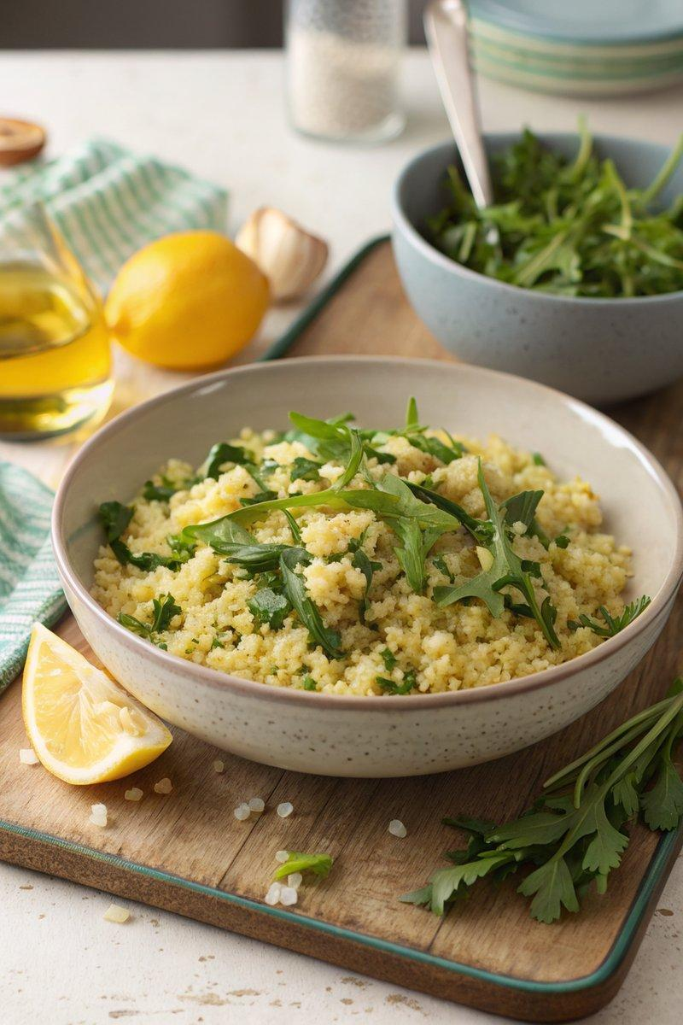

INGREDIENTS  - {'group': 'Main', 'item': '500g couscous'}  - {'group': 'Main', 'item': '800ml chicken or vegetable stock'}  - {'group': 'Main', 'item': '3 tbsp garlic oil'}  - {'group': 'Main', 'item': 'zest and juice of 1 lemon'}  - {'group': 'Main', 'item': '4 spring onions, finely sliced'}  - {'group': 'Main', 'item': '100g rocket leaves'}  - {'group': 'Seasoning', 'item': 'salt and pepper, to taste'} | PREP  Prepare the stock by dissolving concentrate, cube, or granules in boiling water. Zest and juice the lemon, and finely slice the spring onions.  COOK  Heat the garlic oil in a medium saucepan over medium heat. Add the couscous and sauté, stirring constantly, for 2-3 minutes until lightly toasted. Pour in the hot stock, stirring continuously, and cook over low heat until the liquid is absorbed, about 5 minutes. Turn off the heat, cover with a lid, and let it sit for 10 minutes.  PLATING  Fluff the couscous with a fork to separate the grains. Transfer to a large bowl and mix in the lemon zest and juice, sliced spring onions, and season with salt and pepper. Gently fold in the rocket leaves before serving.

NOTES:
This dish pairs well with grilled meats or can be enjoyed on its own as a light meal.

