SPICED LAMB CHOPS WITH BUTTERNUT AND ROCKET SALAD  COOK TIME: 6 mins  SOURCE: Unknown  #lamb #Indian #pan-fry | 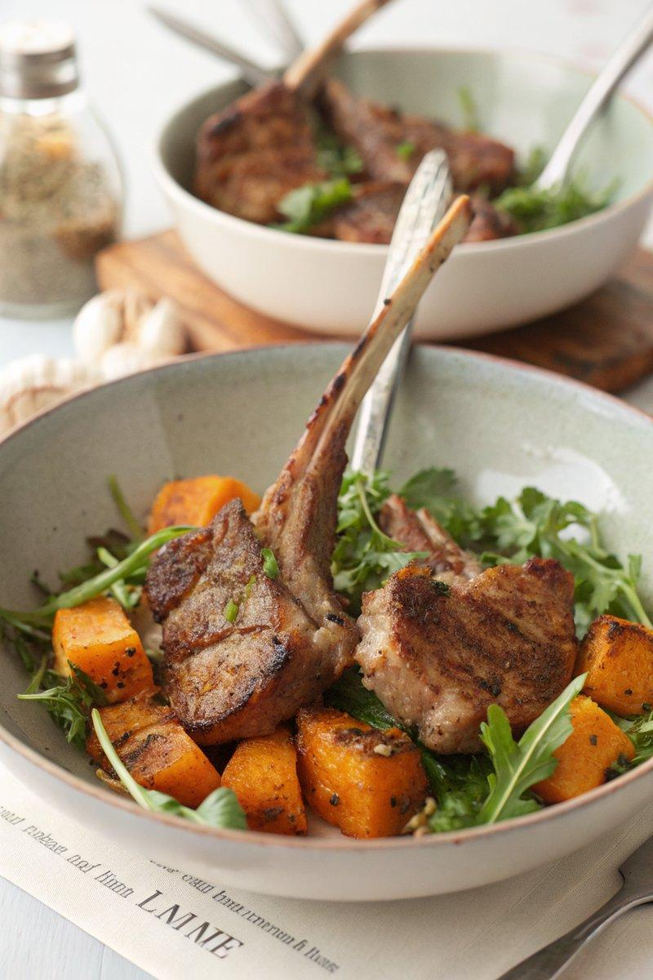

INGREDIENTS  - {'group': 'Main', 'item': '12 small French-trimmed lamb chops or 8 larger lamb chops'}  - {'group': 'Spice Rub', 'item': '1 tsp ground coriander'}  - {'group': 'Spice Rub', 'item': '1 tsp ground cumin'}  - {'group': 'Spice Rub', 'item': '1 tsp ground ginger'}  - {'group': 'Spice Rub', 'item': '1/4 tsp ground cloves'}  - {'group': 'Spice Rub', 'item': '1/2 tsp cayenne pepper'}  - {'group': 'Spice Rub', 'item': '1/2 tsp ground cinnamon'}  - {'group': 'Spice Rub', 'item': '3 tsp sea salt flakes or 1.5 tsp pouring salt'}  - {'group': 'Cooking', 'item': '2 tbsp garlic oil'}  - {'group': 'Salad', 'item': '500g butternut squash, cubed'}  - {'group': 'Salad', 'item': '100g rocket'}  - {'group': 'Salad', 'item': '2 tbsp pine nuts'} | PREP  Measure out the ground coriander, cumin, ginger, cloves, cayenne pepper, cinnamon, and salt into a shallow dish. Mix well to create the spice rub. Cube the butternut squash and set aside.  COOK  Dip the lamb chops into the spice rub, ensuring they are well coated on all sides. Heat the garlic oil in a frying pan over medium heat. Fry the lamb chops for 2-3 minutes on each side until they are darkly burnished but still pink inside. Meanwhile, roast the butternut squash cubes in the oven at 200°C (400°F (200°C)) until tender, about 20 minutes.  PLATING  Arrange the lamb chops on a serving platter. Toss the roasted butternut squash with rocket and pine nuts, then serve alongside the lamb chops.

NOTES:
For a quicker version, use pre-mixed Madras curry powder in place of the individual spices. Ensure the butternut squash is at room temperature before assembling the salad.

