ROASTED BUTTERNUT SQUASH AND ROCKET SALAD  COOK TIME: 30-40 mins  SOURCE: Unknown  #vegetarian #mediterranean #roasted | 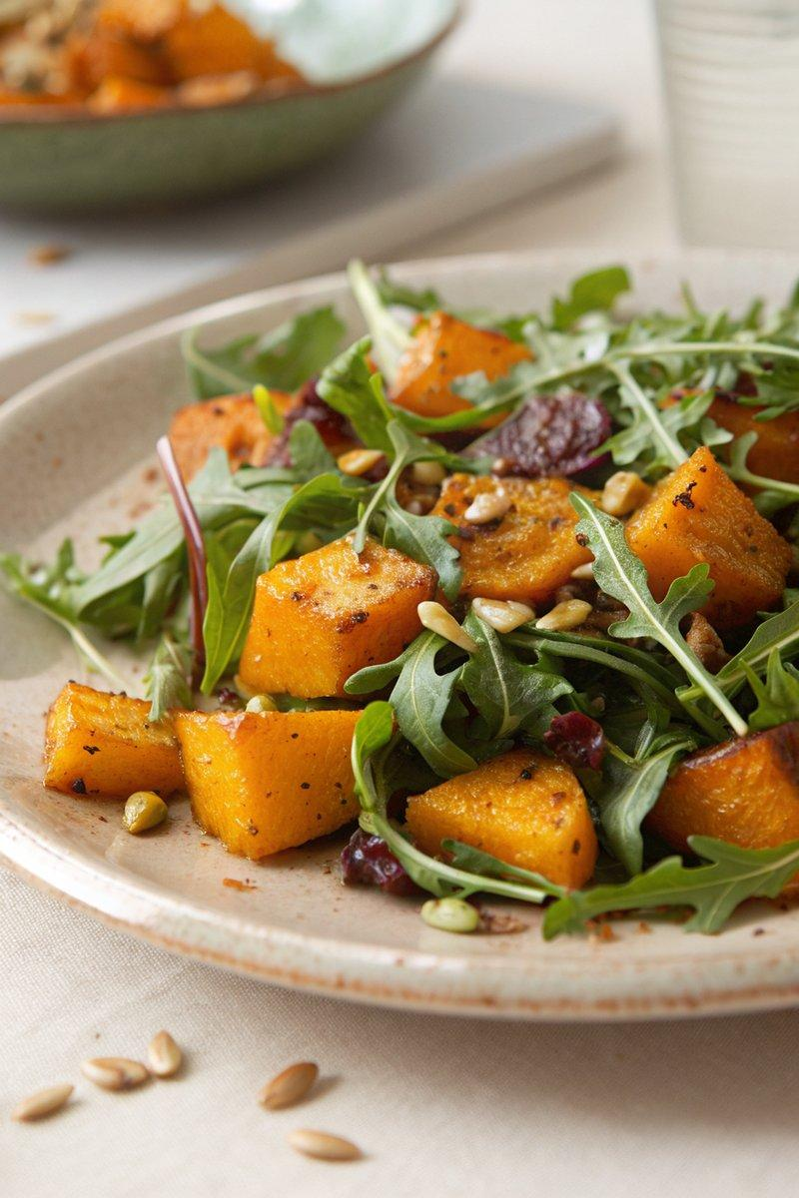

INGREDIENTS  - {'group': 'Main', 'item': '1 butternut squash, ~1kg'}  - {'group': 'Seasoning', 'item': '1 tsp sea salt flakes'}  - {'group': 'Seasoning', 'item': '1 tsp ground turmeric'}  - {'group': 'Seasoning', 'item': '1 tsp ground ginger'}  - {'group': 'Main', 'item': '2 tbsp cold-pressed rapeseed oil or olive oil'}  - {'group': 'Dressing', 'item': '50g golden sultanas'}  - {'group': 'Dressing', 'item': '60ml boiling water'}  - {'group': 'Dressing', 'item': '1 tsp sherry vinegar'}  - {'group': 'Main', 'item': '100g rocket and other salad leaves'}  - {'group': 'Garnish', 'item': '50g pine nuts, toasted'} | PREP  Preheat the oven to 200°C (400°F (200°C)). Halve the butternut squash, remove seeds, and cut into 1.5cm (2-inch) slices, then quarter each slice.  COOK  In a bowl, combine the squash with salt, turmeric, ginger, and 2 tbsp of oil. Mix well and spread on a lined baking tray. Roast for 30-40 mins, checking for tenderness with a fork. Meanwhile, soak sultanas in boiling water in the same bowl used for the squash. Once cooled, whisk in sherry vinegar and remaining oil.  PLATING  Arrange half the salad leaves on a serving platter. Top with roasted squash, remaining leaves, and toasted pine nuts. Drizzle with the sultana dressing and gently toss before serving.

NOTES:
The roasted squash can be prepared a day in advance. Allow it to reach room temperature before assembling the salad.

