SPANISH CHICKEN WITH CHORIZO AND POTATOES  COOK TIME: 1 hr  SOURCE: Unknown  #chicken #Spanish #bake | 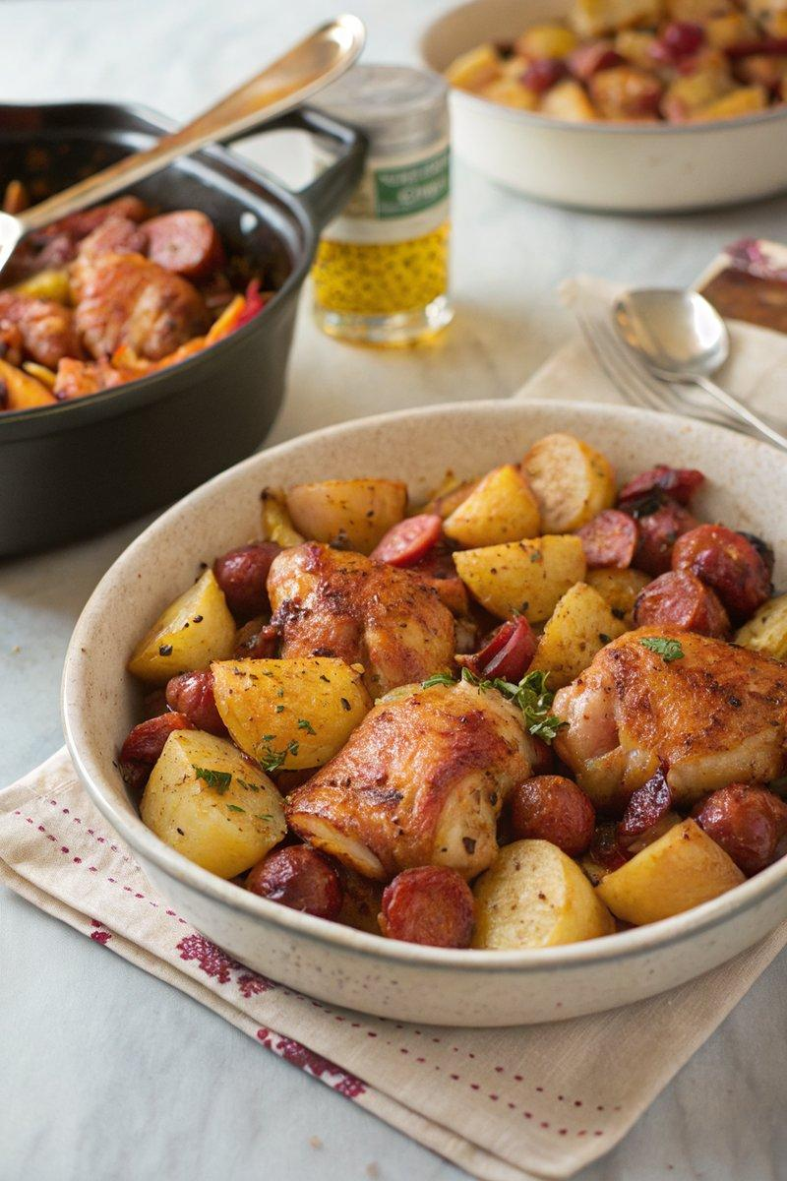

INGREDIENTS  - {'group': 'Main', 'item': '12 chicken thighs, bone-in, skin-on'}  - {'group': 'Main', 'item': '750g chorizo sausages, cut into 4cm chunks'}  - {'group': 'Main', 'item': '1kg new potatoes, halved'}  - {'group': 'Main', 'item': '2 red onions, peeled and roughly chopped'}  - {'group': 'Seasoning', 'item': '2 tsp dried oregano'}  - {'group': 'Seasoning', 'item': 'Grated zest of 1 orange'}  - {'group': 'Main', 'item': '30ml olive oil'} | PREP  Preheat the oven to 220°C (425°F (220°C)). Divide the olive oil between two shallow roasting tins, placing 15ml in each. Rub the chicken thighs with the oil and arrange them skin-side up in the tins.  COOK  Distribute the chorizo chunks and halved potatoes evenly between the two tins. Sprinkle the chopped red onions and dried oregano over the contents. Grate the orange zest over everything. Bake in the oven for 1 hour, swapping the top and bottom trays after 30 minutes and basting with the juices.  PLATING  Serve the chicken, chorizo, and potatoes hot, garnished with the orange-infused juices from the roasting tins. Pair with a fresh green salad for a complete meal.

NOTES:
Leftovers can be reheated within two days. Remove bones from the chicken before reheating. Consider using leftovers in quesadillas with cheese for a quick meal.

