ROASTED CHICKEN THIGHS WITH GREEK HERB SAUCE  COOK TIME: 45 mins  SOURCE: Unknown  #chicken #Mediterranean #roast | 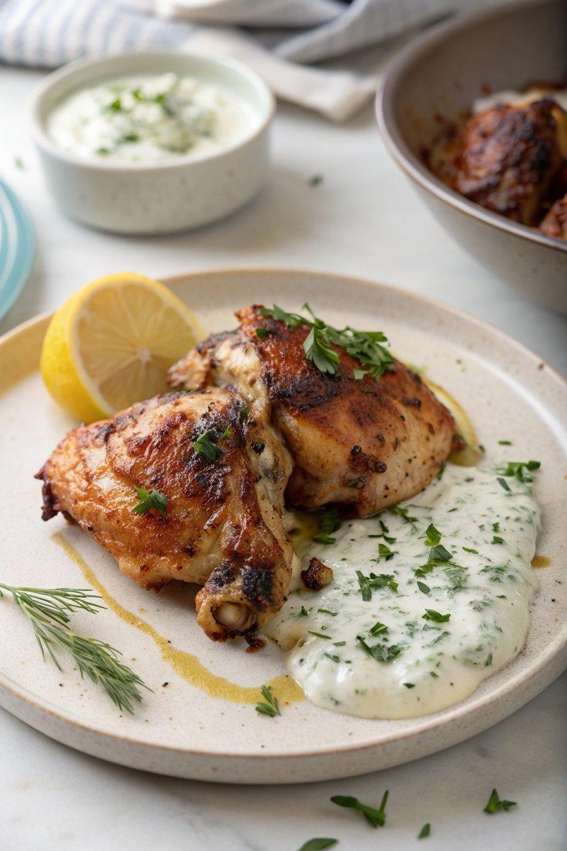

INGREDIENTS  - {'group': 'Main', 'item': '12 chicken thighs, bone-in, with or without skin'}  - {'group': 'Main', 'item': 'juice of 1 lemon'}  - {'group': 'Main', 'item': '60ml olive oil'}  - {'group': 'Main', 'item': 'salt and pepper'}  - {'group': 'Sauce', 'item': '500ml natural Greek yogurt'}  - {'group': 'Sauce', 'item': '4-6 spring onions, finely chopped'}  - {'group': 'Sauce', 'item': '1 green chilli, de-seeded and finely chopped'}  - {'group': 'Sauce', 'item': '1 clove garlic, minced'}  - {'group': 'Sauce', 'item': '1/2 cucumber, peeled and finely diced'}  - {'group': 'Sauce', 'item': '3 tbsp chopped fresh coriander'}  - {'group': 'Sauce', 'item': '3 tbsp chopped fresh mint'}  - {'group': 'Sauce', 'item': '2 tbsp chopped fresh dill'}  - {'group': 'Sauce', 'item': 'salt and pepper, to taste'} | PREP  Preheat the oven to 200°C (400°F (200°C)). In a shallow roasting tin, arrange the chicken thighs skin-side up. Drizzle with lemon juice and olive oil, then season with salt and pepper.  COOK  Roast the chicken in the preheated oven for 45 minutes until the skin is golden and the meat is cooked through. Meanwhile, prepare the sauce by combining Greek yogurt, finely chopped spring onions, de-seeded chilli, minced garlic, diced cucumber, and most of the chopped herbs in a bowl. Mix well and season with salt and pepper to taste.  PLATING  Transfer the roasted chicken to a serving dish. Serve the Greek herb sauce in a separate bowl, garnished with the reserved herbs. Offer baked potatoes on the side for a complete meal.

NOTES:
For a more intense flavour, marinate the chicken in lemon juice and olive oil for a few hours before roasting. The sauce can be prepared in advance and stored in the refrigerator.

