TOMATO CURRY WITH COCONUT RICE  COOK TIME: 25 mins  SOURCE: Unknown  #vegetarian #Indian #sauté | 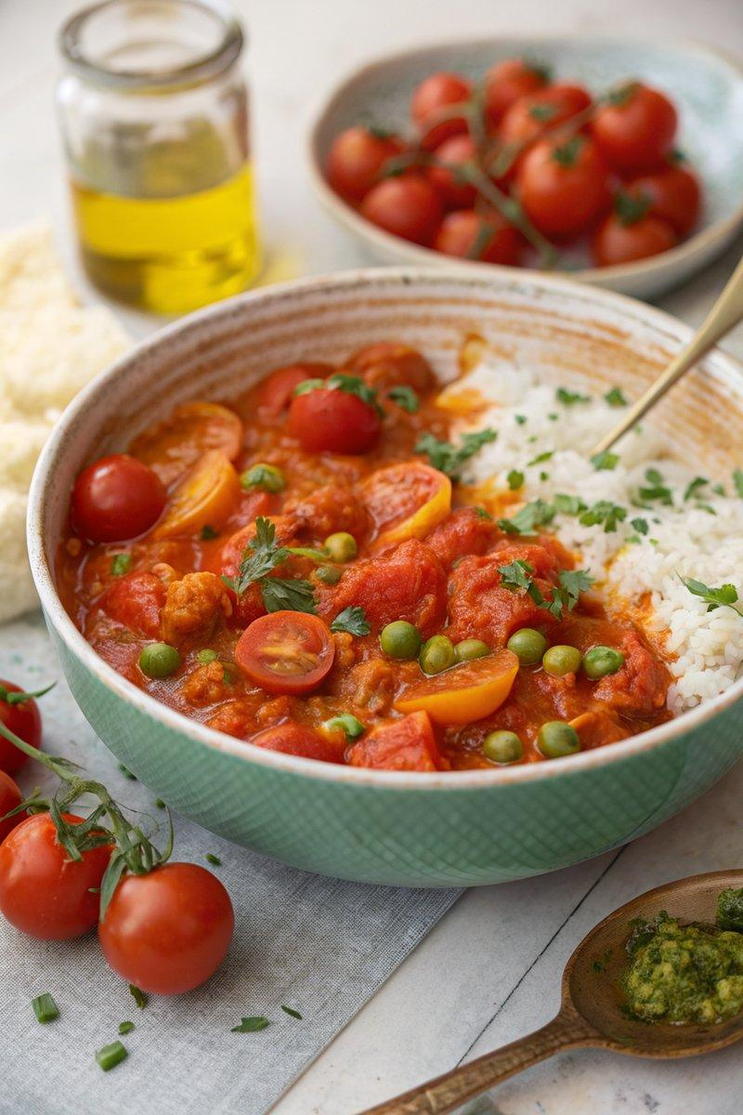

INGREDIENTS  - {'group': 'Main', 'item': '2 tbsp cold-pressed rapeseed oil or olive oil'}  - {'group': 'Main', 'item': '2 large onions, peeled and chopped'}  - {'group': 'Main', 'item': '1 tsp sea salt flakes'}  - {'group': 'Main', 'item': '4 cloves garlic, peeled and chopped'}  - {'group': 'Main', 'item': '1kg cherry tomatoes, halved'}  - {'group': 'Seasoning', 'item': '2 tsp turmeric'}  - {'group': 'Seasoning', 'item': '1 tsp English mustard powder'}  - {'group': 'Seasoning', 'item': '1 tsp hot chilli powder'}  - {'group': 'Seasoning', 'item': '1 tsp garam masala'}  - {'group': 'Main', 'item': '200g frozen peas'} | PREP  Peel and chop the onions and garlic. Halve the cherry tomatoes. Measure out the spices and set aside.  COOK  Heat the oil in a large pan over medium heat. Add the onions and salt, cooking for about 7 mins until soft. Stir in the garlic, then add the tomatoes and spices. Cover and cook on low heat for 20 mins. Meanwhile, boil the peas in salted water, drain, and add to the curry for the last 5 mins of cooking.  PLATING  Serve the tomato curry hot, accompanied by coconut rice, garnished with fresh herbs if desired.

NOTES:
The tomato base can be prepared a day in advance and refrigerated. Reheat gently before adding the peas. The base can also be frozen for up to 3 months.

